Busy Workers,
Meal preparation Manual

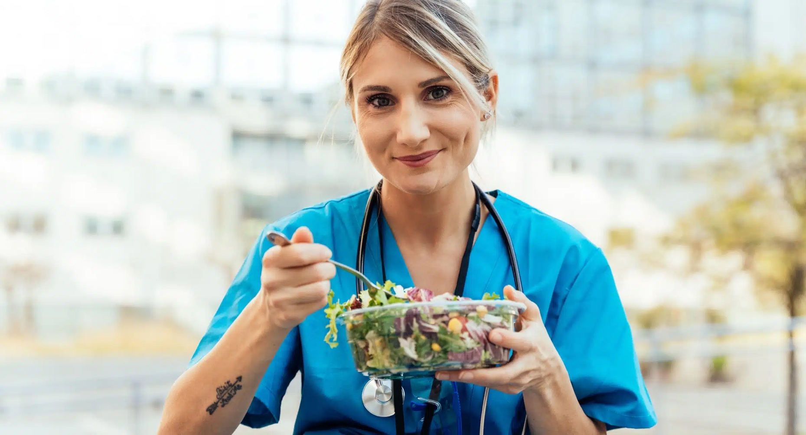

To start healthy lifestyle, healthy eating habits, you need to know the main components of your meals

We use My plate as a guide for what should be included in my meals
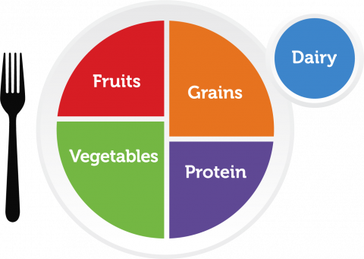

How Does MyPlate Work?
The MyPlate image is a plate that is divided into four sections, with each section representing how much of each food group you should eat. Vegetables make up the largest section, followed by grains. Together, fruits and vegetables fill half the plate while proteins and grains fill the other half.
It may surprise you that MyPlate does not include meat as one of the 5 food groups. Instead, the category “protein” includes fish, shellfish, eggs, beans, peas, nuts, seeds, and soy products, in addition to meat.
A small blue circle on the side of the plate represents dairy. The latest USDA Guidelines include fortified soy alternatives in this category.
This simple model is designed to make it easy for consumers to see what an ideal meal should look like,

https://www.center4research.org/my-plate-dietary-guidelines/

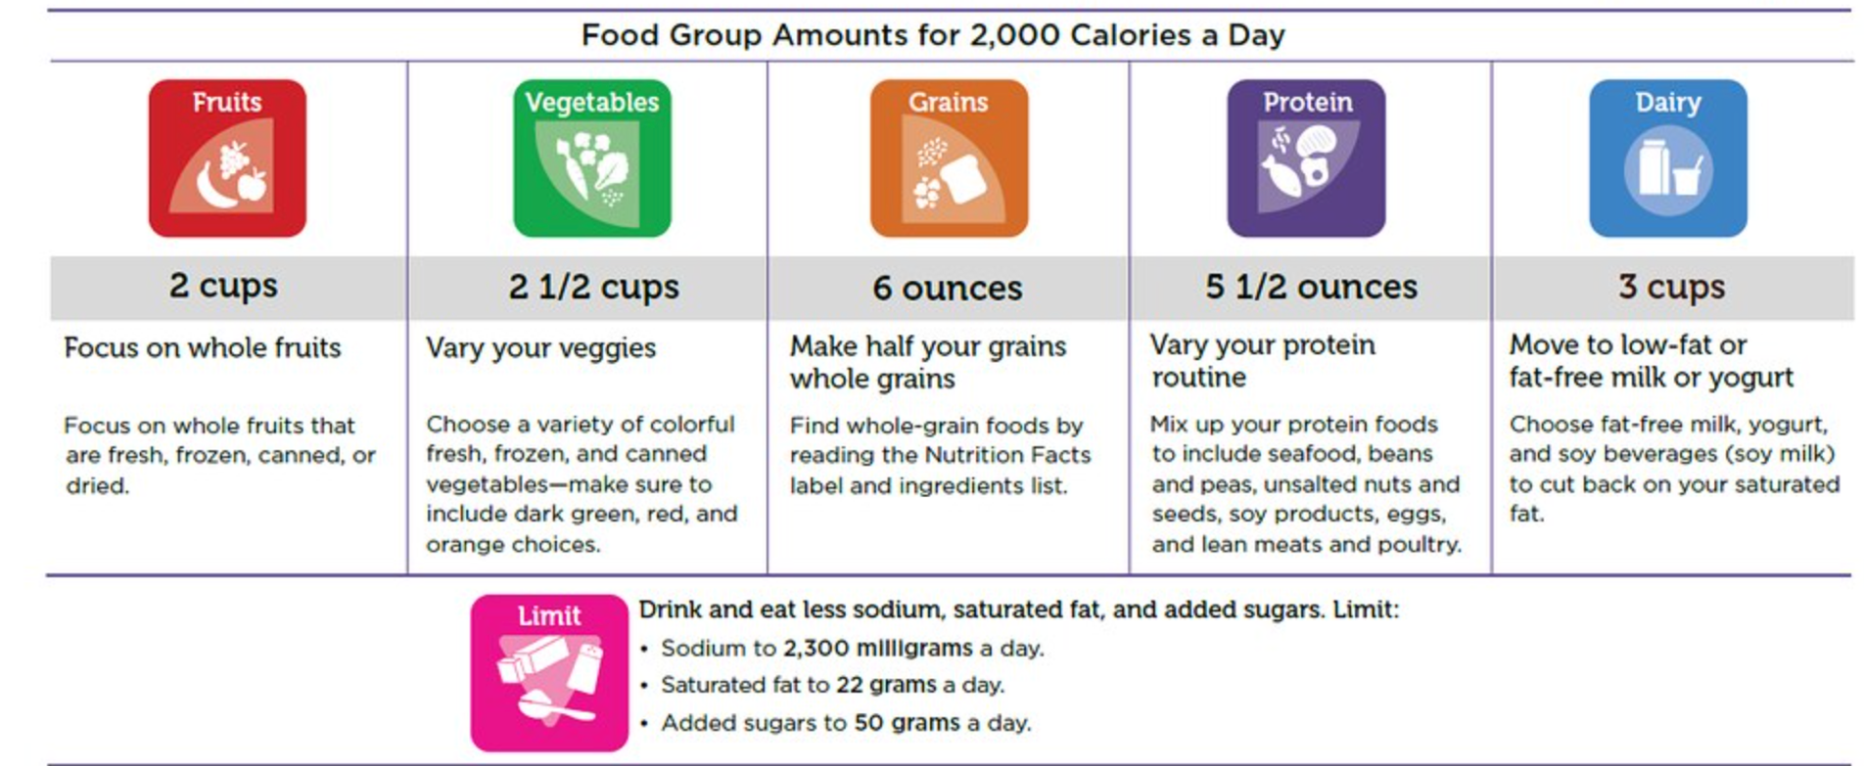

How mutch should I eat from each group?

Fruits: (2 cups)
How much fruit should I eat each day?
Focus on whole fruits. Include fruit at breakfast! Top whole-grain cereal with your favorite fruit, add berries to pancakes, or mix dried fruit into hot oatmeal.
What counts as a cup of fruit?
In general, the following counts as 1 cup from the Fruit Group:
1 cup of fresh, frozen, or canned fruit
½ cup of dried fruit
1 cup of 100% fruit juice
https://www.myplate.gov/eat-healthy/what-is-myplate
Health Benefits of eating Fruits
Focus on variety, amount, and nutrition.
Eating foods such as fruits that are lower in calories per cup, may help lower overall calorie intake, may reduce the risk for heart disease, including heart attack and stroke, may protect against certain types of cancers, and can help increase the amount of fiber and potassium we eat.

Vegetables: 2 ½ cup
How many vegetables are needed daily?
The following examples count as 1 cup from the Vegetable Group:
1 cup of raw, cooked, frozen, or canned vegetables
2 cups of raw leafy salad greens
1 cup of 100% vegetable juice
Health Benefits of eating vegetables
Focus on variety, amount, and nutrition.
eating foods lower in calories per cup, such as vegetables, instead of higher-calorie food may help you lower your calorie intake, may reduce the risk for heart disease, including heart attack and stroke, may protect against certain types of cancers, and helps increase fiber and potassium, which many Americans do not get enough of.

Grains: 6 Ounces
How much Grains are needed daily?
Grains have two subgroups: whole grains and refined grains.
Eaxamples:
whole grains | Refined grains.
bran, germ, and endosperm. | white flour, corn grits, white bread, and white rice.
whole-wheat flour, bulgur (cracked wheat), oatmeal, and brown rice | The word "enriched" should appear in the grain name.
What counts as an ounce-equivalent (oz-equiv) of grains?
The following are some grain food portions that are equal to one ounce:
1 slice of bread
1 cup of ready-to-eat cereal
½ cup of cooked rice, cooked pasta, or cooked cereal
Health Benefits of eating Grains:
Focus on variety, amount, and nutrition.
Eating whole grains as part of a healthy diet may reduce the risk of getting heart disease, can support healthy digestion, and may help with weight management.

Protein: 5 ½ ounces
Protein Foods include all foods made from seafood; meat, poultry, and eggs; beans, peas, and lentils; and nuts, seeds, and soy products. Beans, peas, and lentils are also part of the Vegetable Group.
How much Protein are needed daily?
Meat and poultry choices should be lean or low-fat, like 93% lean ground beef, pork loin, and skinless chicken breasts. Choose seafood options that are higher in healthy fatty acids (called omega-3s) and lower in methylmercury, such as salmon, anchovies, and trout.
What counts as an ounce-equivalent in the Protein Foods Group?
The following examples count as 1 ounce-equivalent from the Protein Foods Group:
1 ounce of meat, poultry, or fish
¼ cup cooked beans
1 egg
1 tablespoon of peanut butter
½ ounce of nuts or seeds
¼ cup (about 2 ounces) of tofu
1 ounce tempeh, cooked
Health Benefits of eating Protein:
Proteins function as building blocks for bones, muscles, cartilage, skin, and blood. They are also building blocks for enzymes, hormones, and vitamins. Proteins are one of three nutrients that provide calories (the others are fat and carbohydrates).

Dairy : 3 cups
The Dairy Group includes milk, yogurt, cheese, lactose-free milk and fortified soy milk and yogurt.
The Dairy Group does not include foods made from milk that have little calcium and a high fat content. Examples of this are cream cheese, sour cream, cream, and butter
How Much dairy are needed daily?
What counts as a cup in the Dairy Group?
In general, the following counts as 1 cup from the Dairy Group:
1 cup of milk, yogurt, or soy milk
1 ½ ounces of natural cheese

Health Benefits for drinking/ eating Dairy
Focus on variety, amount, and nutrition.
Calcium and vitamin D are important nutrients at any age. Eating or drinking dairy products that have these nutrients help to:
Improve bone health, especially in children and adolescents when bone mass is being built.
Promote bone health and prevent the start of osteoporosis in adults.

For those who choose not to eat or drink dairy products

Choose fortified soy milk and yogurt with added calcium, vitamin A, and vitamin D are a part of the Dairy Group. This is because their nutrition content is like dairy milk and yogurt.
Other products sold as “milks” but made from plants like almond, rice, coconut, oat, and hemp “milks” may have calcium. But, they are not a part of the Dairy Group because their nutrition content is not like dairy milk and fortified soy milk.
There are calcium choices for those who do not eat or drink dairy products. However, these are not part of the Dairy Group.
The amount of calcium your body can absorb (or take in) from these foods may vary.
- Calcium-fortified juices
- Calcium-fortified plant-based milk alternatives, such as rice milk or almond milk
- Canned fish, such as sardines and salmon with bones
- Tofu made with calcium sulfate
- Tahini, such as sesame butter or paste
- Some leafy greens, such as collard and turnip greens, spinach, kale, and bok choy

Food group | Tips
Fruits | Include fruit at breakfast  Top cereal with your favorite seasonal or frozen fruit  Take fruit on the go  Fruits like oranges, bananas, and apples are great portable snacks.  Make your own trail mix  Combine one or two favorite breakfast cereals with dried cranberries and raisins.  Enjoy fruit as a snack  Make fruit kabobs using melon chunks, bananas, and grapes. Top with a light yogurt sauce.  Add fruit at dinner  Chop up a combination of tropical or seasonal fruits to make a fruit salsa to top fish or chicken, or add fruit like grapefruit sections, apple wedges, or grapes to a tossed salad.  Keep fruit on hand  Cut up fruit and place in a bowl in the refrigerator. Put the bowl at the front of the shelf so that it’s the first thing you see when you open the door.
Vegetables | Start your day with vegetables  Add leftover cooked vegetables to your omelet or breakfast wrap. Or, add spinach to a morning smoothie and enjoy a burst of flavor and nutrition!  Add variety to salads  Make your salad pop with color and flavor by including corn kernels, radish slices, or diced red onions. Include seasonal vegetables for variety throughout the year.  Try a stir-fry  Stir-fry vegetables like carrots, shredded cabbage, greens, and low-sodium jarred mushrooms for a quick meal.  Spruce up your sandwich  Add spinach or some thinly sliced sweet onions to your favorite sandwich or wrap for extra flavor and a little crunch.  Go for a dip or a dunk  Enjoy baked potato wedges, cucumber slices, or cauliflower pieces with a homemade Italian dressing or dunked into a low-fat dip or hummus.  Take vegetables on the go  Carry along some crunchy carrot, celery, or jicama sticks. A small container of cherry tomatoes or sugar snap peas also make an easy snack.
Grains | Have whole grains at breakfast  Oatmeal is a favorite, but consider trying a grain that’s new to you, like buckwheat or millet. You might find a new breakfast favorite.  Enjoy a multigrain bowl  Create a one-dish meal by layering a mixture of grains like barley or wild rice with some colorful veggies and some low-fat cheese. Add your favorite protein and a dash of hot pepper sauce.  Swap your sandwich bread  Look for sandwich-type breads made with whole grains. Pita, tortillas, naan, sliced breads, and rolls are all available as whole grains.  Choose whole grain takeout  Ask about whole grain options when dining out or ordering take-out food.  Experiment with a new grain  Cook a new grain like quinoa, amaranth, or millet..  Switch up pizza night  Create individual, homemade pizzas on whole-wheat English muffins or tortillas.
Protein | Include protein in your snack  peanut or nut butter as a dip for apple or celery slices, or as a spread on whole grain crackers.  A hard-cooked (hard-boiled) egg with a dash of pepper .  Keep seafood on hand  Canned seafood, such as salmon, tuna, or crab.  Add protein to your salad  Add Grilled chicken, shrimp, Chickpeas or black beans to a salad of mixed greens.  Take protein on the go  Pack a mixture of unsalted nuts and sunflower seeds for a crunchy snack. Add some dried fruit like  raisins, cranberries, or chopped dates for a touch of sweetness.  Get creative with beans, peas, and lentils  Make chili or stews with kidney or pinto beans,or enjoy lentils as a side dish.  Serve up lean meat  Broil lean beef cuts like sirloin, top round, or flank steak. Sliced into strips, they’re great over greens, or in a sandwich.
Dairy | Include dairy in the morning  cereal with low-fat or fat-free dairy milk or soy beverage. Or, top plain low-fat or fat-free yogurt with a serving of fruit and nuts to include two more food groups.  Look for calcium sources  If you don’t consume milk, look for calcium-fortified foods  Fit dairy into meals  Prepare oatmeal and canned condensed soups with low-fat or fat-free dairy milk or fortified soy beverage instead of water. Adding milk or soy beverage to smoothies, quiche, and mashed potatoes is another good idea.  Create your own dressing  Blend plain low-fat or fat-free dairy yogurt, lemon juice, and dried or fresh herbs such as basil and parsley for a salad dressing. You may use it as a dip  Drink up!  Grab a glass of milk.  Snack on homemade cheese spread  Blend low-fat ricotta cheese with herbs such as oregano and dill, and sprinkle on some chopped green onions. Serve with whole grain crackers.

Portion Control:
Knowing what a single portion of food actually looks like can be tricky. Some times its hard to have mesuring cups or spoons, but the attached visual will help make the portions easier by using the size of your hand, showing what single portions of different types of food actually look like.

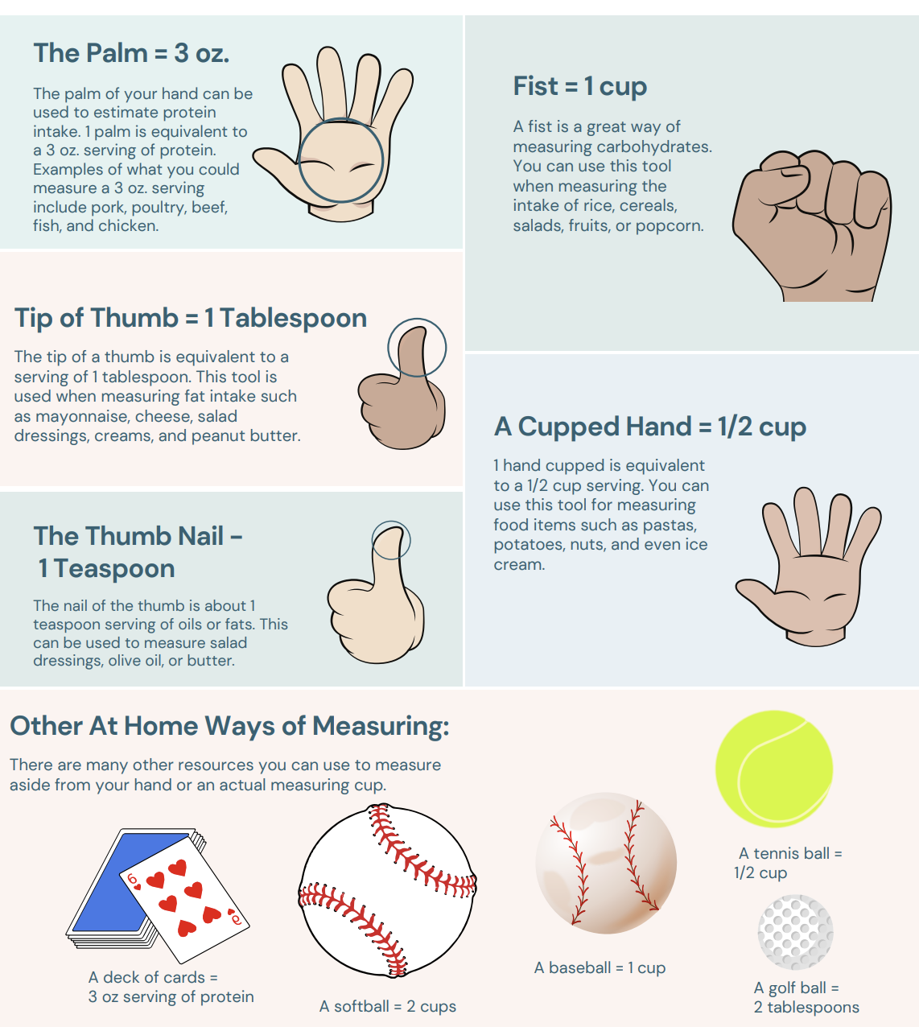
https://www.siue.edu/campus-recreation/facilities/EstimatingPortionSizesUsingYourHands.pdf

10 Healthy eating habits and tips:
- Cut down on added sugars, saturated fat, and sodium
Added sugars are sweeteners with calories that food companies add to foods and drinks or that you add at home. Choose water instead of sugary drinks and limit sweet treats like cake, cookies, and candy.
Saturated fat is higher in animal foods like butter, cheese, whole milk, and fatty meats like ribs and sausage. It’s also in some plant foods like coconut oil and palm oil. Choose foods with unsaturated fats instead like seafood, avocados, nuts and seeds, and olive oil.
Sodium comes from salt, and most of the sodium we eat comes from packaged foods and restaurant meals. Try cooking more at home and flavoring foods with herbs and spices instead of salt.
- Choose whole grains
Whole grains are a healthier choice than refined grains. Try: Whole wheat bread instead of white bread, Corn or whole-wheat tortillas instead of white flour tortillas Plain popcorn instead of corn chips
https://odphp.health.gov/our-work/nutrition-physical-activity/dietary-guidelines/current-dietary-guidelines/toolkit-professionals#build-healthy-routines-lifespan
- Always Pack a lunch
Plan meals in advance: at the weekend decide on your lunches for the week to streamline the packing process and ensure you have a variety of healthy options.
Prepare ingredients ahead of time: choose a day to wash and chop vegetables, cook grains, and portion out snacks on the weekend or evenings to save time during the week.
Consider leftovers: Leftovers can be a great way to save time and reduce food waste. Simply pack up extra portions from dinner into your lunch containers.
Make in bulk: Prepare larger batches of dishes like chili, soup, or pasta salad, then divide them into individual portions for easy grab-and-go lunches
- Practice "mindful" eating at work
Put away your phone and step away from your workstation. Find a place where you can focus on what you are eating and how you feel. This can help you enjoy your meal more and prevent overeating.
- Adjust diet for shift work. If you are a shift worker, try to stick to a normal day pattern of food intake (eating “dinner” before your shift and “breakfast” at end of shift). Drink water regularly and keep caffeinated beverages to the beginning of your shift.
- Plan ahead! Use your weekends or time off to plan your lunches for the week and get the ingredients you need. A local greenmarket might be a good place to find organic produce. Take an actual break to eat your lunch. Taking a break is sometimes hard to do but it decreases stress, can give you time to move and stretch, talk to others, and refresh your mind.
- Choose water. Drink water instead of sugary beverages like juice or soda. Try to track your drinking and keep a bottle of water on your desk
https://www.mountsinai.org/files/MSHealth/Assets/HS/Patient-Care/Service-Areas/Occupational-Medicine/Eating%20Healthy%20at%20Work.pdf
- Read and understands food lable:

The information in the main or top section contains product-specific information (serving size, calories, and nutrient information). The bottom section contains a footnote that explains the % Daily Value and gives the number of calories used for general nutrition advice. We you decide to buy a product you can take a quick look on 4 main pieces of information that helps to compare products content and decide which one to buy.
Serving Information
look at the number of servings in the package (servings per container) and the serving size. Serving sizes are standardized to make it easier to compare similar foods; they are provided in familiar units, such as cups or pieces, followed by the metric amount, e.g., the number of grams (g). The serving size reflects the amount that people typically eat or drink. It is not a recommendation of how much you should eat or drink.

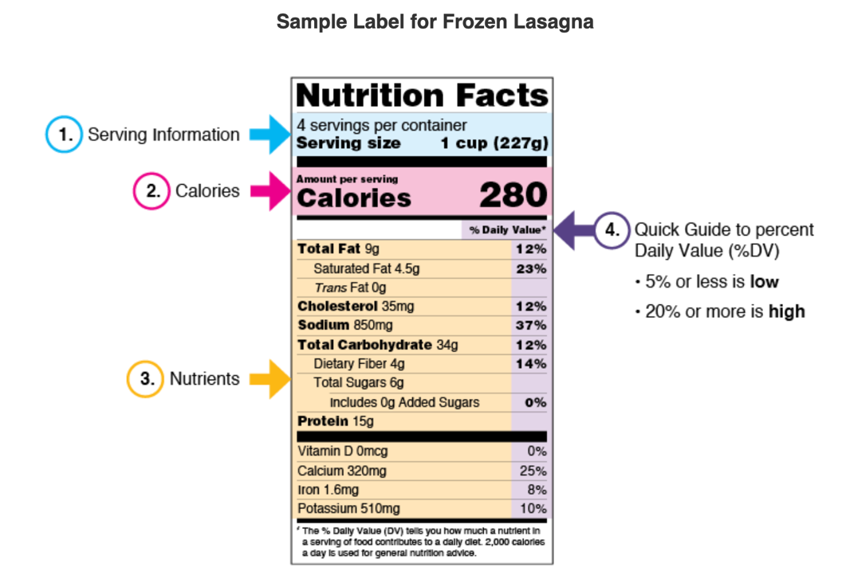

Calories

Calories provide a measure of how much energy you get from a serving of this food. If the container have 2 serving you have to double the calories per serving if you decided to eat the whole container.

Nutrients

Nutrients to get less of: Saturated Fat, Sodium, and Added Sugars.
Total Sugars label includes sugars naturally present in many nutritious foods and beverages, such as sugar in milk and fruit as well as any added sugars .
Added Sugars include sugars that are added during the processing of foods.
Nutrients to get more of: Dietary Fiber, Vitamin D, Calcium, Iron, and Potassium.

The Percent Daily Value (%DV)

The % Daily Value (%DV) is the percentage of the Daily Value for each nutrient in a serving of the food. The Daily Values are reference amounts (expressed in grams, milligrams, or micrograms) of nutrients to consume or not to exceed each day.

The %DV shows how much a nutrient in a serving of a food contributes to a total daily diet.

The %DV helps you determine if a serving of food is high or low in a nutrient.

General Guide to %DV

5% DV or less of a nutrient per serving is considered low

20% DV or more of a nutrient per serving is considered high
- Have healthy snacks in stock such as:

Granola bars, fresh ordired fruites, crackers, cheese sticks, low far fruit yougurt, low fat protein drink, can of Tuna salad, trail mix…etc
- Focus on Hydration:
Hydration Tips:
The general recommendation is to drink 8 glasses of water per day, but that varies depending on your activity levels, size, and individual health needs. Instead of depending on thirst, you should drink water, 5 to 7 ounces, every 15 to 20 minutes.
Here are a few tips that can be used in the office, making it easier to stay hydrated at work:
- Take a water bottle that you love!
- Avoid Other Beverages: Skip soda and coffee in favor of water. calories.
- Enjoy it and add Flavor: add small amount of fruit juice or add chunks of fruit.
- Track Your Intake: Look for a system that fits in your workflow. you can try using a phone app that reminds you to take another drink.
- Drink Extra in the Morning: Prepare for the workday by drinking plenty of water first thing in the day.
- Switch Your Snacks: This tip isn’t about drinking water, but it is a critical factor that can affect your hydration. Prepackaged, processed food tends to have low water content, which can dehydrate you when you need an afternoon snack. Instead of munching on pretzels or chips, bring snacks with high water content such as fruit, smoothies, or veggies.
Section 2:
Meal Planning for Busy Workers
Basic tools:
Pots and Pans
  - 8-quart pot with lid. For boiling pasta, steaming vegetables (with an insert) and making soups and stews. Be sure to pick one that you can comfortably carry when it’s full of liquid.
  - 4-quart saucepan with lid. Does what the 8-quart does on a smaller scale. Good to have around when other pans are in use or when you are preparing a smaller amount of food.
  - 2-quart saucepan with lid. For cooking rice or other grains, making sauces, heating up canned goods and leftovers.
  - 12-inch nonstick skillet. For sautéing meats and vegetables. If you get a deep one with rounded sides it can work well for stir-fries, too.
  - 8-inch nonstick skillet. Perfect for omelets, eggs, or that grilled sandwich for lunch.
  - Steamer insert. A collapsible one will fit into a variety of pan sizes.
Sharp Stuff
  - Chef’s knife. 8 or 10-inch
  - Paring knife. 4 or 6-inch
  - Serrated knife. 8-inch, great for slicing bread and tomatoes.
  - Cutting board. Buy two: a plastic one for raw meat and a wooden one for breads, fruit and vegetables. Make it a habit to thoroughly wash and dry anything that has touched raw meat before using it again to reduce risk of foodborne illness.
  - Box grater. It’s the most versatile kind of grater, usually with six different grating sizes. For just zesting, it’s hard to beat a microplane.
  - Vegetable peeler. Get a nice one with a comfortable handle.
  - Can opener. The smooth-cut kind opens the can from the outside edge, so the lid won’t fall in.
  - Kitchen shears. Useful for trimming everything from fat from meat to the tips of green beans or snow peas
Mixing and Lifting
  - Wooden spoons. They’re both versatile and inexpensive, so get several.
  - Slotted spoon. Stainless steel, wood or plastic, for stirring and dipping into hot and cold liquids.
  - Ladle. For serving soups and stews. A standard size ladle holds ½ cup or 1 cup, for easy portion measuring.
  - Spatula. Get a non-metal one that won’t damage your nonstick cookware.
  - Rubber scraper spatula. For getting out that last little bit. Silicon ones can be used for hot stuff.
  - Whisk. Great for salad dressing and sauces. Also useful for combining dry ingredients in baking.
  - Tongs. Like having hands that don’t burn or freeze. Get a spring-loaded one.
https://www.heart.org/en/healthy-living/healthy-eating/cooking-skills/meal-planning/essential-kitchen-equipment-and-utensils
Other tools and utensils in your kitchen will make your meals easier and faster
  - Mixing bowls.
  - Measuring cups.
  - Measuring spoons.
  - Timer.
  - Colander.
  - Instant-read thermometer.
  - Oven mitts or pot holders, kitchen towels, apron.
  - air fryer
  - Blender
  - Food Processor
  - Mandoline
  - Glass Canning Jars
  - Containers

Section 3:
Cooking on a Budget
Grocery List example:
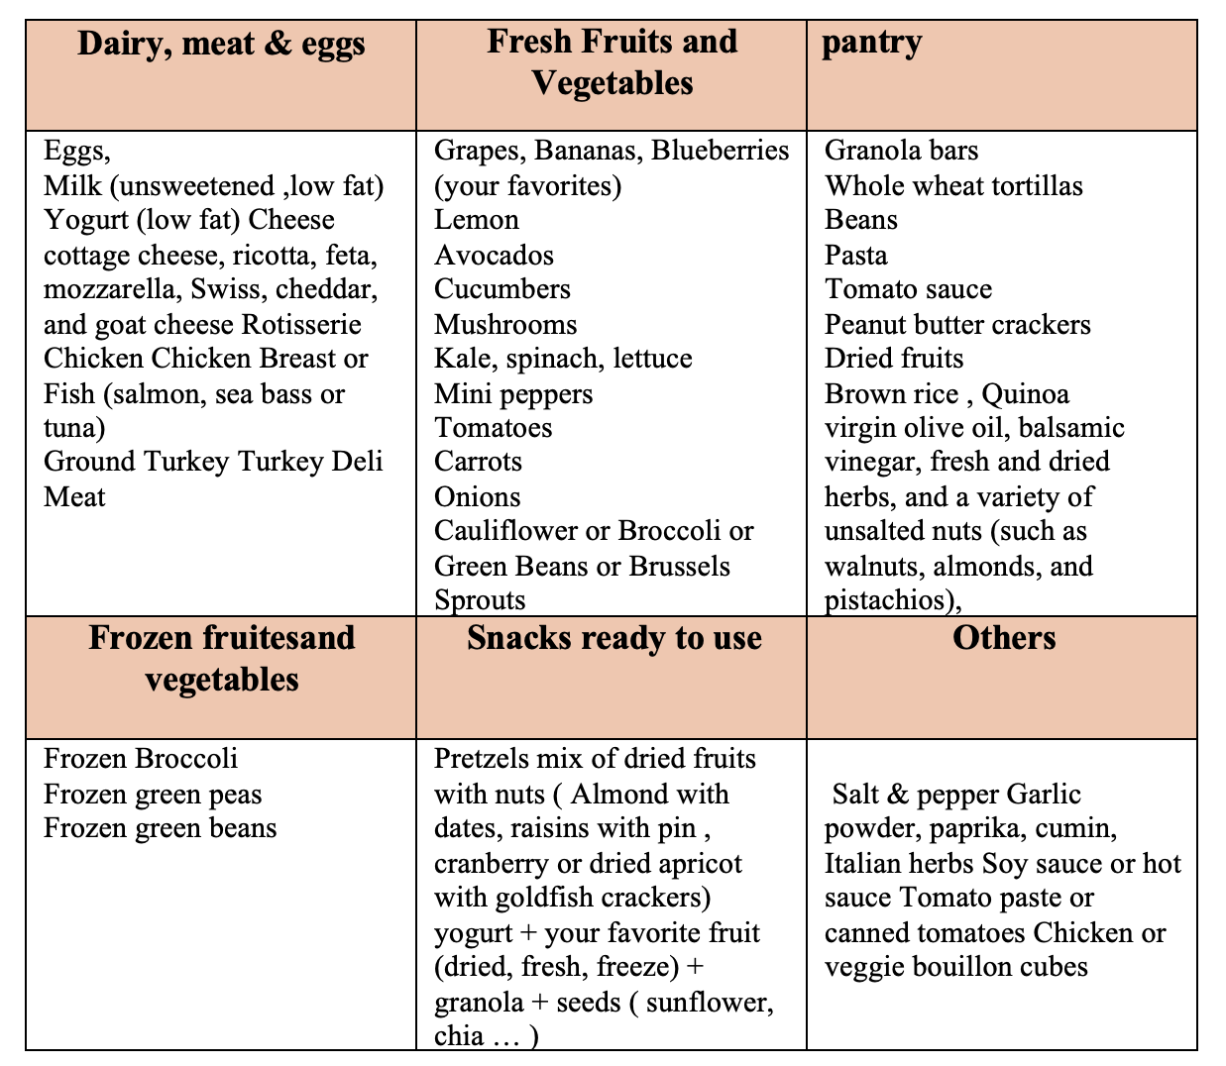
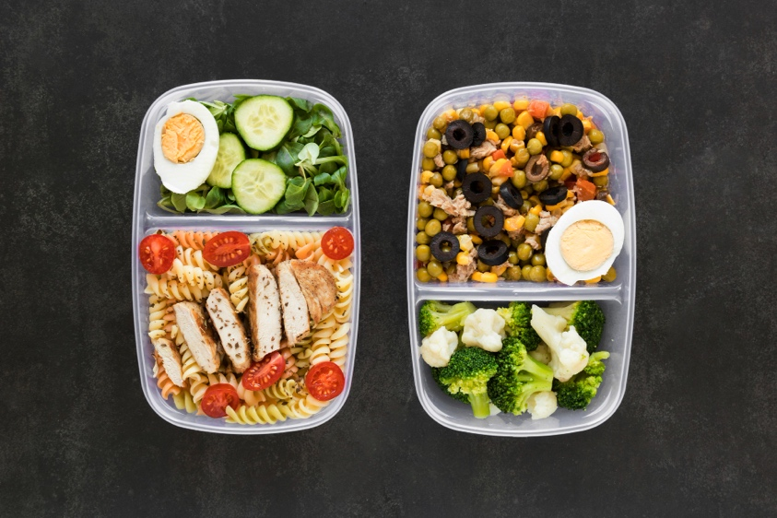

Suggested recipes:
Salad:
Pasta Salad
Ingredients | Preperation
12 ounces whole-wheat rotini (spiral-shaped) pasta  1 tablespoon olive oil  1/4 cup low-sodium chicken broth  1 garlic clove, chopped  2 medium onions, chopped  1 can (28 ounces) unsalted diced tomatoes in juice  1 pound mushrooms, sliced  1 red bell pepper, sliced  1 green bell pepper, sliced  2 medium zucchini, shredded  1/2 teaspoon basil  1/2 teaspoon oregano  8 romaine lettuce leaves | Cook and Drain the pasta thoroughly. Place pasta in a large serving bowl. Add the olive oil and toss. Set aside.  In a large skillet, heat the chicken broth over medium heat. Add the garlic, onions and tomatoes. Saute until the onions are transparent, about 5 minutes. Add the remaining vegetables and saute until tender-crisp, about 5 minutes. Stir in the basil and oregano.  Add the vegetable mixture to the pasta. Toss to mix evenly. Cover and refrigerate until well chilled, about 1 hour.

https://www.mayoclinic.org/healthy-lifestyle/recipes/pasta-salad-with-mixed-vegetables/rcp-20049830

Teriyaki Chicken Salad
Ingredients (4 servings) | Preperation
1 tablespoon extra-virgin olive oil  1 pound boneless, skinless chicken thighs, trimmed  2 tablespoons hoisin sauce  2 tablespoons light brown sugar  2 tablespoons reduced-sodium tamari or soy sauce  2 tablespoons mirin  2 tablespoons seasoned rice vinegar  1 teaspoon grated garlic  1 teaspoon grated fresh ginger  4 cups chopped romaine hearts  2 cups thinly shredded green cabbage  1 small red bell pepper, sliced (about 1 cup)  1 medium carrot, peeled and shredded (½ cup)  ½ cup seeded, halved and thinly sliced English cucumber  2 large scallions, thinly bias-sliced (½ cup)  1 small serrano pepper, unseeded and thinly sliced (about 1½ tablespoons)  1 tablespoon toasted sesame seeds  Crispy fried onions or fried shallots (optional | Heat 1 tablespoon oil in a large nonstick skillet over medium-high heat. Add trimmed chicken thighs; cook, flipping once, until browned and an instant-read thermometer inserted in the thickest portion registers 165°F, about 10 minutes.  Meanwhile, whisk 2 tablespoons each hoisin, brown sugar, tamari (or soy sauce), mirin and vinegar and 1 teaspoon each grated garlic and ginger together in a small bowl. Set aside 6 tablespoons of the dressing for serving.
https://www.eatingwell.com/teriyaki-chicken-salad-11731945

Chicken, Avocado Cream and Quinoa Salad-in-a-Jar (4 servings)
Ingredients | Preperation
3/4 cup red quinoa  1/2 cup cilantro leaves and tender stems, finely chopped, plus sprigs for garnish  1 scallion, thinly sliced  1 tablespoon olive oil  Kosher salt  1 firm-ripe avocado, halved, pitted and cut into large chunks  1/4 cup sour cream  3 tablespoons grated Parmesan  Juice of 1 lime, plus 1 lime, quartered  Pinch cayenne pepper  1 1/2 cups frozen fire-roasted corn, thawed  2 cups shredded rotisserie chicken meat (from about 1/2 chicken; about 3/4 pound)  1 cup black bean salsa  1/4 cup roasted and salted pepitas  2 cups tortilla chips, crushed | Make the quinoa: Bring the quinoa and 1 1/4 cups water to a boil in a large saucepan over medium-high heat. Cover, reduce heat to medium-low and gently simmer until the quinoa is tender (the little tails will pop out) and most of the water is absorbed, 20 to 25 minutes. Drain off any excess water. Stir in the cilantro, scallions, oil and 1/2 teaspoon salt. Serve warm or at room temperature. (The quinoa can be cooled, covered and refrigerated for up to 2 days. Microwave just enough to take the chill off, about 2 minutes, stirring about halfway through.)  Make the avocado cream: Process or blend the avocado, sour cream, Parmesan, lime juice, 1 to 2 tablespoons water, cayenne and 3/4 teaspoon salt in a food processor or blender until smooth and creamy.  If the corn still has a chill, microwave it for about 1 minute.  Assemble the salads: Using four 16-ounce wide-mouthed glass jars with lids, divide the quinoa evenly among the jars, then add the following in separate layers: the corn, chicken, salsa, avocado cream and pepitas. Pack the crushed tortilla chips (about 1/4 cup per salad) and lime wedges in separate small containers for transporting  Just before serving, transfer the jarred ingredients to a large bowl, add the tortilla chips and a squeeze of lime juice and toss.
https://www.foodnetwork.com/recipes/food-network-kitchen/chicken-avocado-cream-and-quinoa-salad-in-a-jar-3363404

Chickpea "Chicken" Salad (4 servings)
Ingredients | Preperation
½ cup canola mayonnaise  3 tablespoons chopped fresh flat-leaf parsley  2 tablespoons chopped fresh dill  1 ½ teaspoons country-style Dijon mustard  ½ teaspoon kosher salt  ½ teaspoon smoked paprika  ¼ teaspoon ground pepper  2 (15 ounce) cans no-salt-added chickpeas, rinsed  ½ cup chopped celery (from 2 stalks)  ¼ cup finely chopped shallot (from 1 large shallot) | Combine mayonnaise, parsley, dill, mustard, salt, paprika and pepper in a bowl. Add chickpeas, celery and shallot; stir until well coated.
https://www.eatingwell.com/recipe/275502/chickpea-chicken-salad/

Fattoush Salad

Ingredients | Preperation
1pita bread  1large tomato, diced, seeds removed  ¼red onion, diced  2bell peppers, one red, one yellow, pith and seeds removed, cut into long strips  1cucumber, peeled and cut in rounds  5radishes, sliced  2whole scallions, chopped  1head of romaine lettuce, purslane or other wild greens  ¼cup coarsely chopped fresh mint  1 to 3teaspoons ground sumac, available in Middle Eastern markets  1teaspoon dried mint  For the Dressing  2cloves garlic, peeled and minced (about 2 teaspoons)  ⅓cup extra virgin olive oil  Juice of ½ lemon  4teaspoons pomegranate syrup  1teaspoon salt, or to taste  ¼teaspoon ground pepper, or to taste | Heat oven to 350 degrees. Separate pita into 2 rounds, and bake on cookie sheet for about 5 minutes, or until very crisp but not browned.  Put tomato, red onion, peppers, cucumber, radishes and scallions into large salad bowl.  Add romaine or purslane and fresh mint, and sprinkle with sumac and dried mint. Toss  Whisk together garlic, olive oil, lemon juice, pomegranate syrup, and salt and pepper in a small bowl. Just before serving, give dressing another quick whisk and then pour it over vegetables and toss.  Break pita into 1-inch pieces and toss with salad, just before taking salad to table. Taste, add seasonings if needed, and serve immediately.

https://cooking.nytimes.com/recipes/10709-fattoush

Sandwiches and wraps:

Chicken Tacos
Ingredients | Preperation
4 ounces shredded or chopped precooked chicken (approx. ¾ cup)  3 butter lettuce leaves  ½ cup fresh salsa  2 tablespoons guacamole | If desired, warm chicken by putting it in a microwavable bowl and heating it on medium power for 1 minute. Divide chicken among leaves. Top with fresh salsa and gucamole and serve.
https://www.transamericainstitute.org/resources/cookbooks?gad_source=1&gad_campaignid=11017520140&gbraid=0AAAAACN4UZLUGGb2nVj_uj2KtTFPcUTLe&gclid=CjwKCAjwv5zEBhBwEiwAOg2YKAsGDJm5gjn5QAqB6W9XdijDwNxHkX-feX6UZFtGIEfaUSI_aJ8rWBoCasAQAvD_BwE

Roasted Buffalo Chickpea Wraps (vegetarian)
Ingredients (4 wraps) | Preperation
1 tablespoon white vinegar  ½ teaspoon cayenne pepper, or to taste  ¼ teaspoon salt  1 (15 ounce) can no-salt-added chickpeas, rinsed  ¼ cup whole-milk plain Greek yogurt  1 tablespoon hot sauce, such as Frank’s RedHot  ¼ cup crumbled blue cheese  2 cups chopped red leaf or romaine lettuce  ½ cup shredded carrot  ½ cup thinly sliced celery  4 8-inch spinach or whole-wheat wraps | Position rack in upper third of oven; preheat to 400 degrees F.  Combine vinegar, cayenne and salt in a large bowl. Very thoroughly pat chickpeas dry, then toss with the vinegar mixture.  Spread on a rimmed baking sheet.  Roast the chickpeas, stirring twice, until browned and crunchy, 30 to 35 minutes.  Meanwhile, combine yogurt and hot sauce in a small bowl.  Stir in blue cheese.  Divide lettuce, carrot and celery among wraps.  Top each with 1/4 cup of the chickpeas and 2 tablespoons sauce.  Roll up. Cut in half to serve, if desired.
https://www.eatingwell.com/recipe/261765/roasted-buffalo-chickpea-wraps/

Avocado, Tomato & Chicken Sandwich (one serving)
Ingredients | Preperation
2 slices multigrain bread  ¼ ripe avocado  3 ounces cooked boneless, skinless chicken breast, sliced (see Tip)  2 slices tomato | Toast 2 slices bread. Mash 1/4 avocado with a fork and spread onto 1 piece of toast. Top with 3 ounces chicken, 2 slices tomato and the second piece of toast
https://www.eatingwell.com/recipe/250881/avocado-tomato-chicken-sandwich/

Spicy Tuna Wrap (4 servings)
Ingredients | Preperation
2 5- to 6-ounce cans chunk light tuna (see Notes), drained  ⅓ cup low-fat mayonnaise  1 tablespoon hot sauce, such as Sriracha (see Notes)  1 scallion, chopped  2 cups cooked brown rice (see Tip), cooled  2 tablespoons rice vinegar  4 10-inch whole-grain wraps  3 cups watercress leaves  1 ripe avocado, cut into 16 slices  1 small carrot, cut into matchsticks  Reduced-sodium soy sauce for dipping (optional) | Combine tuna, mayonnaise, hot sauce and scallion in a medium bowl. Combine rice and vinegar in a small bowl.  Spread one-fourth of the tuna mixture over a wrap. Top with 1/2 cup rice, 3/4 cup watercress, 4 avocado slices and one-fourth of the carrot matchsticks. Roll up and cut the wrap in quarters or in half. Repeat with the remaining filling and wraps. Serve with soy sauce for dipping, if desired.
https://www.eatingwell.com/recipe/250246/spicy-tuna-wrap/

Kale Turkey Wraps
Ingredients | Preperation
1 tablespoon cranberry sauce  1 teaspoon Dijon mustard  3 medium lacinato kale leaves  3 slices deli turkey (about 3 ounces)  6 thin red onion slices  1 firm ripe pear, cut into 9 slices | Mix cranberry sauce and mustard in a small bowl. Spread on kale leaves. Top each leaf with a slice of turkey, 2 slices red onion and 3 slices pear. Roll each leaf into a wrap. Cut each wrap in half, if desired.
https://www.eatingwell.com/recipe/255768/kale-turkey-wraps/

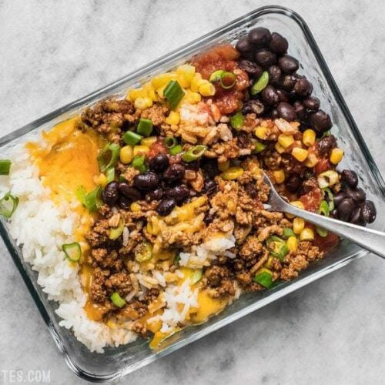
Meals and Bowls :

Burrito Bowl ( 4 servings)
Ingredients | Preperation
4 cups cooked rice  1 lb. ground turkey or beef  1 cup frozen corn kernels  1 15oz. can black beans  4 oz. cheese (about 1 cup shredded)  1 1/3 cup salsa | Cook the rice first.  add the ground turkey or beef to a skillet and cook over medium heat until it is cooked through.  Thaw the corn kernels, rinse and drain the black beans, shred the cheese, and slice the green onions.. Divide the remaining six bowl ingredients between the containers as well (taco meat, corn, beans, cheese, salsa, and green onions).
https://www.budgetbytes.com/easiest-burrito-bowl-meal-prep/
CAULIFLOWER ALFREDO

Ingredients | Preperation
12 ounces whole grain or legume-based pasta 4 cups cauliflower, cut into florets  2 tablespoons extra virgin olive oil, plus a small amount for pasta  4 garlic cloves, chopped  ½ cup whole milk  ¼ cup shredded Parmesan cheese  ⅛ teaspoon fine sea salt  ⅛ teaspoon black pepper  ½ teaspoon red pepper flakes  ¼ cup fresh parsley, finely chopped | In a large pot of boiling water, cook pasta according to package instructions. Then turn off heat, drain pasta (keeping 1 cup of pasta water), add pasta back to pot, and stir in a drizzle of olive oil to prevent sticking. Cover pot with lid. 2. Meanwhile, steam cauliflower florets until soft, about 15 minutes. 3. 4. Add oil to a large skillet over medium heat. Add garlic and cook until fragrant, about 1 minute. Combine garlic, cooled cauliflower, whole milk, Parmesan, salt, pepper, and red pepper flakes in food processor or large blender. If the sauce is too thick, add reserved pasta water, 1 tablespoon at a time.  Over low heat, add sauce to cooked pasta and toss until coated. Remove from heat, garnish with parsley, and serve immediately

https://www.transamericainstitute.org/resources/cookbooks?gad_source=1&gad_campaignid=11017520140&gbraid=0AAAAACN4UZLUGGb2nVj_uj2KtTFPcUTLe&gclid=CjwKCAjwv5zEBhBwEiwAOg2YKAsGDJm5gjn5QAqB6W9XdijDwNxHkX-feX6UZFtGIEfaUSI_aJ8rWBoCasAQAvD_BwE
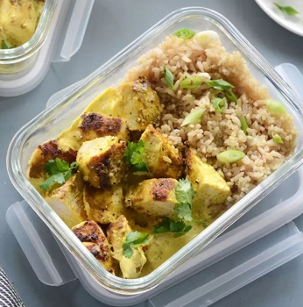
Curried Chicken Bowls (4 servings)

Ingredients | Preperation
1 cup cooked brown rice  1 cup cooked quinoa  1 pound cooked Curried Chicken  ¼ cup chopped fresh cilantro  ¼ cup thinly sliced scallions | Combine rice and quinoa; divide among 4 single-serving containers with lids. Top with chicken, cilantro and scallions, dividing evenly. Seal the containers and refrigerate for up to 4 days
https://www.eatingwell.com/recipe/268334/meal-prep-curried-chicken-bowls/

Air-Fryer Turkey Stuffed Peppers

Ingredients | Preperation
3 medium red bell peppers  1 tablespoon olive oil  12 ounces ground turkey  ½ cup cooked brown rice  ¼ cup panko breadcrumbs  ¾ cup low-sodium marinara sauce  3 tablespoons finely chopped flat-leaf parsley  ¼ teaspoon ground pepper  ¼ cup grated Parmesan cheese (1 oz.)  ¼ cup shredded part-skim mozzarella cheese (1 oz.) | Coat the basket of an air fryer with cooking spray. Cut tops off peppers and reserve. Seed the peppers and set aside.  Heat oil in a large skillet over medium-high heat. Add turkey; cook, stirring occasionally, until browned, about 4 minutes. Stir in rice and panko; cook, stirring occasionally, until warmed through, about 1 minute. Remove from heat and stir in marinara, parsley, pepper and Parmesan.  Divide the mixture evenly among the prepared peppers.  Place the peppers in the prepared air-fryer basket. Nestle the pepper tops in the bottom of the basket. Cook at 350°F until the peppers are tender, about 8 minutes. Top with mozzarella; cook until the cheese is melted, about 2 minutes more

https://www.eatingwell.com/recipe/270287/air-fryer-turkey-stuffed-peppers/

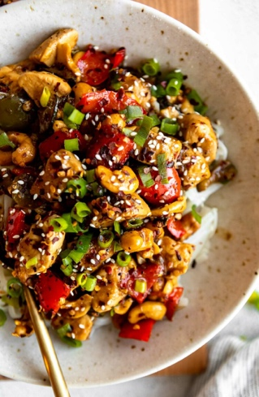
Spicy Cashew Chicken Noodle Bowls

Ingredients | Preperation
Cashew Chicken Recipe  Rice Noodles – I love using these rice noodles for this recipe!  Chicken Breast  Bell Peppers – You’ll need 1 red bell pepper and 1 green.  Zucchini  Roasted Cashews  Green Onion  Minced Garlic  Avocado Oil – Or any type of cooking/vegetable oil.  Sauce  Chicken Broth  Low Sodium Tamari – Or low sodium soy sauce!  Rice Vinegar  Grated Ginger – Freshly grated ginger is best, but 1 teaspoon of ginger powder works great, too.  Salt/Black Pepper  Tapioca Starch – Cornstarch works great, too.  Honey  Red Pepper Flakes – Adjust the amount to taste | Cook the rice noodles according to package directions  While the noodles cook, whisk together the sauce ingredients.  In a saute pan or skillet, cook the chicken, bell peppers, zucchini, and lightly toast the roasted cashews. Add the sauce and let it simmer for a few minutes to slightly thicken  Divide the noodles into bowls, then top with the cashew chicken, any extra sauce, green onions, sesame seeds, extra crushed red pepper, or anything else you like!

Dips:
You can take sliced vegetables or roasted whole wheat bread to eat with the dip

All kind of dip can be combind with fresh vegetables strips or/ and whole wehate bread pieces or Pretzels

Baba ganoush

Ingredients | Preperation
1 Big Beetroot  1 tsp Coarse salt  1 tsp Black pepper  1 tsp Cumin  4-5 Cloves of Garlic  1 tbsp Olive Oil  1 Cup Hung Yogurt | Cut the wedges of beetroot and place them in a foil  Sprinkle salt, pepper, cumin garlic cloves, and drizzle oil on the top. Roughly wrap the beet in the foil and bake minutes at 200* C in a preheated oven, until tender.  As the roasted beet cools down, blend it in a mixer to get a very fine smooth paste. If required pass it through a sieve.  In a bowl whisk the hung yogurt, using a wire whisk. Add in the pureed beet paste. whisk them together and your beetroot dip is ready. Check and adjust the seasoning before.

(Pink Dip )Beetroot Dip

Ingredients | Preperation
2 cooked beets (not in vinegar)  7oz/200g feta cheese  2 tablespoons cream cheese  2 garlic cloves  1 tablespoon lemon juice  1 tablespoon olive oil  1/2 teaspoon salt  To serve –  1 tablespoon olive oil  1 tablespoon nutty dukkah  Handful of fresh thyme leaves | Add the beets, feta, 2 tablespoons of cream cheese, 2 garlic cloves, 1 tablespoon of lemon juice, 1 tablespoon of olive oil and 1/2 teaspoon of salt to the bowl of a food processor, or into a blender. Blitz for a couple of minutes, until a smooth, creamy sauce forms. Scrape down the edge of the bowl, then blitz for another couple of minutes to make sure everything is properly mixed. Taste, then add a little more salt if it needs something extra (this will depend on how salty your feta is). For a looser consistency, add a little more olive oil.  Drizzle 1 tablespoon of olive oil on top, followed by the thyme leaves and the dukkah. Serve with your favourite crackers and enjoy.

https://2blissofbaking.com/healthy-beetroot-dip/

Muhammara Dip

Ingredients | Preperation
2 red bell peppers  4 tbsp Extra Virgin Olive Oil divided  1/4 lb shelled toasted walnuts  1 garlic clove roughly chopped  2 1/2 tbsp tomato paste  3/4 cup bread crumbs  2 tbsp pomegranate molasses  1 tsp Aleppo pepper  1/2 tsp sugar  1 tsp sumac  1/2 tsp salt  1/2 tsp cayenne pepper optional | Preheat the oven to 425 degrees F.  Brush the bell peppers with 1 tbsp of olive oil, and place in a lightly oiled oven-safe pan or cast-iron skillet. Roast the peppers in the 425 degrees F heated oven for 30 minutes or so, turning them over once or twice  Remove from the oven and place the peppers in a bowl. Cover with plastic wrap for a few minutes. simply peel the peppers, remove the seeds and slice the peppers into small strips.  Now in the bowl of a large food processor, combine the roasted red pepper strips with 3 tbsp extra virgin olive oil, garlic, walnuts, tomato paste, bread crumbs, pomegranate molasses, Aleppo pepper, sugar, sumac, salt and cayenne. Blend into a smooth paste.  Transfer to a serving bowl. bring the dip to room temperature before serving.  When ready to serve, top the dip with a drizzle of extra virgin olive oil, and garnish with a little more walnuts and fresh parsley, if you like. Serve with pita bread or pita chips. Enjoy!
https://www.themediterraneandish.com/muhammara-recipe-roasted-red-pepper-dip/

Greek Yogurt Dip

Ingredients | Preperation
Greek yogurt: Reduced-fat  Salt, pepper, ground cumin, and chili powder.  Fresh herbs: Parsley or cilantro. finely chopped for the best texture. You may use ½ teaspoon of dried herbs instead.  Optional topping: Chopped chives. | Add all the ingredients to a small serving bowl.  Mix them by hand with a rubber spatula. There's no need for any special equipment!  Allow the dip to rest for ten minutes at room temperature before serving.

Snacks:

Quick easy to go snacks you can take from home :
- Pretzels
- mix of dried fruits with nuts ( Almond with dates, raisins with pin , cranberry or dried apricot with goldfish crackers)
- yougurt + your favorite fruit (dried, fresh, freezed) + granola + seeds ( sunflower, chia … )
- freez dried fruits
- vegetable chips
- granola bars (try to chose the lowest fat and sugar content)
- rice cake with a spread such as Hummus or avocado + sliced vegetables

Peanut Butter & Berries Waffle Sandwich

Ingredients | Preperation
1 whole-wheat freezer waffle, toasted  1 tablespoon crunchy natural peanut butter  ¼ cup fresh mixed berries, such as raspberries, strawberries and blackberries  ½ teaspoon honey | Slice waffle in half down the center. Spread peanut butter over one half.  Place berries in a small bowl and smash with the back of a fork. Spread on top of the peanut butter layer and then drizzle with honey. Top with the remaining waffle half

Banana Energy Bites

Ingredients | Preperation
1 overripe banana  1 cup dry quick-cooking rolled oats  ½ cup roasted and salted pumpkin seeds (pepitas)  ½ cup dried cranberries  ½ cup natural peanut butter  ¼ cup miniature semisweet chocolate pieces | In a medium bowl mash banana with a fork until smooth. Stir in oats; pumpkin seeds, dried cranberries, peanut butter and chocolate pieces. Using 1 tbsp. for each bite, shape into 32 balls; flatten slightly. Chill until ready to serve

https://www.eatingwell.com/recipe/263832/banana-energy-bites/
Peanut Butter-Oat Energy Balls
Ingredients | Preperation
¾ cup chopped Medjool dates  ½ cup rolled oats  ¼ cup natural peanut butter  Chia seeds for garnish | Soak ¾ cup dates in a small bowl of hot water for 5 to 10 minutes. Drain.  Combine the soaked dates, ½ cup oats and ¼ cup peanut butter in a food processor and process until very finely chopped. Roll into 12 balls (a scant tablespoon each). Garnish with chia seeds, if desired. Refrigerate for at least 15 minutes and up to 1 week
https://www.eatingwell.com/recipe/258084/peanut-butter-oat-energy-balls/

Rice Pudding
Ingredients | Preperation
¾ cup long-grain rice  1 ½ cup water  ¼ tsp. salt  4 cups 2% milk  ½ cup brown sugar  1 tsp. vanilla extract  ½ tsp. cinnamon  1 cup raisins (optional)  you may add crunchu almond on top | Combine rice, water and salt in a large sauce pan and bring to a boil. Once it has reached a boil, reduce heat to low and simmer until the rice has absorbed all of the water. Add milk, sugar, and cinnamon to the rice, and cook uncovered at medium heat, stirring frequently. Once the pudding has reached a thick but creamy consistency (about 30 minutes), remove it from the heat. Stir in the vanilla and raisins. Transfer to a large bowl, or smaller serving bowls, cover and refrigerate 2-4 hours or until cool.

https://www.organic-center.org/recipes/grandma%E2%80%99s-rice-pudding?gad_source=1&gad_campaignid=1532452075&gbraid=0AAAAADm5F2tQ1xvxW6Yj48V1zIwiq4CR-&gclid=CjwKCAjwqKzEBhANEiwAeQaPVXBmBrLhab40r4_V9shDlJyOG-xYPD-XxfnoUwTEpyPFdWkhG0L0vRoClQYQAvD_BwE

Date & Oat Bliss Balls (12 balls)

Ingredients | Preperation
1cup packed dates pitted  ¾ cup nuts I used walnuts  ½ cup organic natural creamy peanut butter crunchy or smooth  ¾ cup rolled oats  ½ cup flaked unsweetened coconut  ¼ cup ground flaxseed  3 TBS water or more as needed | In bowl of food processor add the pitted dates, nuts and coconut.  Process until nuts have broken down into small pieces and mixture is sticky.  Add in oats, peanut butter and flaxseed ; process until mixture comes together, adding water 1 tablespoon at a time towards the end.  The mixture may feel crumbly, but should be moist and hold together once formed into balls.  Add a little bit of water and continue to process if needed.  Using a tablespoon size cookie scoop, shape mixture into balls and place on parchment lined baking sheet.  Coat in your choice of toppings. I used melted dark chocolate and unsweetened shredded coconut. Or you can leave them plain.  Place baking sheet in freezer for 20 minutes before transferring to container of your choice.  Can be stored in an airtight container in fridge up to two weeks, freeze up to three months
https://simplybeautifuleating.com/2024/05/07/date-oat-bliss-balls/

Rice cake with hummus

Ingredients | Preperation
1 sliced bell pepper + ¼ cup guacamole  1 cup baby carrots & celery sticks + ¼ cup hummus  1 cup shelled edamame + sprinkle of dulse flakes  2 rice cakes + ¼ cup hummus + chopped tomatoes & cucumbers | Spread hummus over the rice cake  Use guacamole as a dip for the sliced vegetables

Breakfast:

Muffin-Tin Omelets with Feta & Peppers (6 servings) (12omelets)

Ingredients | Preperation
2 tablespoons extra-virgin olive oil  ¾ cup diced onion  ¼ teaspoon salt, divided  1 medium red bell pepper, diced  1 tablespoon finely chopped fresh oregano  8 large eggs  ¾ cup crumbled feta cheese  ½ cup low-fat milk  ½ teaspoon ground pepper  2 cups chopped fresh spinach  ¼ cup sliced Kalamata olives | Preheat oven to 325°F.  Heat 2 tablespoons oil in a large skillet over medium heat. Add ¾ cup onion and ⅛ teaspoon salt; cook, stirring occasionally, until starting to soften, about 3 minutes. Add diced bell pepper and 1 tablespoon oregano; cook, stirring, until the vegetables are tender and starting to brown, 4 to 5 minutes more. Remove from heat and let cool for 5 minutes.  Whisk 8 eggs, ¾ cup feta, ½ cup milk, ½ teaspoon pepper and the remaining ⅛ teaspoon salt in a large bowl. Stir in 2 cups spinach, ¼ cup olives and the vegetable mixture, including any residual oil. Liberally coat a 12-cup muffin tin with cooking spray. Divide the egg mixture among the prepared muffin cups (about ¼ cup each).  Bake until firm to the touch, 25 to 30 minutes. Let stand for 5 minutes before removing from the tin.

https://www.eatingwell.com/recipe/277641/muffin-tin-omelets-with-feta-peppers/

Berry Smoothie Bowl
Ingredients | Preperation
Smoothie base  1 1/2 cups plain yogurt  1 banana, frozen  1/2 cup orange juice  1 cup berries of your choice  1 tablespoon flaxseeds  1 scoop vanilla plant-based protein powder, optional  Toppings  1 tablespoon slivered almonds  1 teaspoon chia seeds  1 tablespoon pomegranate seeds | Blend all base ingredients together until smooth, adjusting for sweetness and thickness  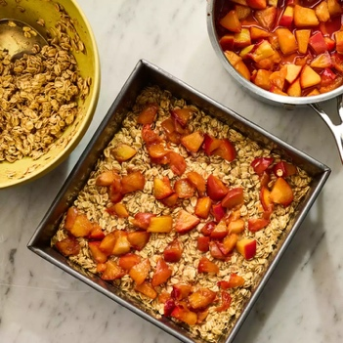  Serve immediately in a large bowl with toppings  or keep thetopping separate in a bag and just add it when you want to eat it.
\

Peach-Oatmeal Breakfast Bars
Ingredients | Preperation
2 medium peaches, chopped (about 2½ cups)  6 tablespoons dark brown sugar, divided  1 tablespoon lemon juice  ¾ teaspoon salt, divided  ⅔ cup whole milk  2 large eggs  1 tablespoon chia seeds  1 tablespoon vanilla extract  ½ teaspoon baking powder  ½ teaspoon ground cinnamon  ½ teaspoon ground cardamom  2½ cups old-fashioned rolled oats | Combine chopped peaches, 1½ tablespoons brown sugar, 1 tablespoon lemon juice and ¼ teaspoon salt in a small saucepan. Cook over medium heat, stirring occasionally, until starting to gently simmer. Reduce heat to medium-low and continue to cook, stirring occasionally, until the peaches have softened and released juices, about 12 minutes. Transfer to a small heatproof bowl and let cool to room temperature, about 30 minutes.  Meanwhile, preheat oven to 375°F. Lightly coat an 8-inch-square baking pan with cooking spray. Whisk ⅔ cup milk, 2 eggs, 1 tablespoon chia seeds, 1 tablespoon vanilla, ½ teaspoon each baking powder, cinnamon and cardamom, and the remaining 4½ tablespoons brown sugar and ½ teaspoon salt in a large bowl until combined.  Fold 2½ cups oats into the milk mixture until combined. Spoon about half (about 1 cup) of the oat mixture into the prepared pan; spread in an even layer. Spoon 1 cup of the peach mixture over the oat mixture; spread the remaining oat mixture over the peaches. Top with the remaining ½ cup peach mixture  Bake until just set in the center and golden brown on top, 25 to 30 minutes. Let cool in the pan on a wire rack for 5 minutes before slicing.

https://www.eatingwell.com/peach-oatmeal-breakfast-bars-11740158

Walnut, Zucchini and Potato Pancakes (12 pancakes) 1 serving = 2 pancakes
Ingredients | Preperation
1 tablespoon plus 1 teaspoon extra virgin olive  1 cup onion, diced fine  ½ cup whole-wheat flour  1 tablespoon baking powder  1 teaspoon salt  3 tablespoons nonfat skim milk or almond milk | heat a nonstick sauté pan; add 1 teaspoon olive oil and the onions. Sauté on low heat until theuntil the onions are golden and caramelized; remove and set aside.  While onions are sautéing, squeeze excess water out of grated zucchini and reserve.  In a a small bowl, combine whole-wheat flour, baking powder and salt, and set asid  In a blender add potatoes and skim milk and blend until pureed. Add in the bowl of dry ingredients and blend until well- mixed  Pour blender ingredients into a large mixing bowl; fold in grated zucchini and sautéed onions.  Heat nonstick sauté pan; add 1 tablespoon olive oil.  When pan is hot, add quarter cup amounts of potato mixture and spread out to form 4-inch pancakes.  Sauté until golden brown on each side. Sprinkle with toasted walnuts. Try serving with broccoli or a light mixed greens salad
https://health.clevelandclinic.org/recipe-walnut-zucchini-potato-pancakes

Mix and match your own salad Jar

Pro Tips
- The dressing goes at the bottom of the jar. Make sure you add your dressing to the bottom of the jar first! The ingredients you add next will be marinated.
- Use wide-mouth jars. It’s much easier to get the ingredients in and out of the jars with a wide mouth.
- Go for pre-cooked and pre-chopped for a shortcut. You maky use Mandoline to make easier and faster.

- Leave a little room at the top. You want to leave a little room at the top of the jar so you can shake it up right before serving.
- Pour the salad into a bowl to eat.
- Store these salads
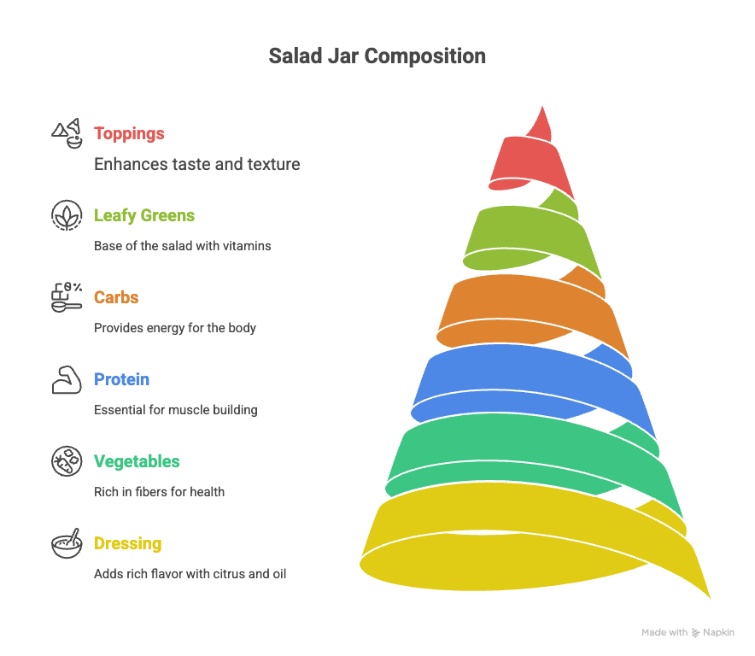
- upright in the fridge.

Make your own Salad jar or Salad dish
Toppings | cilantro, chives, parsly | Seeds such as pumpkin seeds, Hemp seeds | Nuts : Almond, Walnut, Pistachios, pecans | Olive | Kemchi | Dried fruits
Leafy greens | Baby spinich | Kele, swiss chard | Shreded cabbage, arugula | Lettuce , spring mix | Brusseles sprouts | Cilantro, parsly,
Carbs | Quinoa, whole wjeat pasta, | Potato , carrot , green peas | Corn , | Sweet potato , potato, | Mango, pomegrant, citrus fruits | Barly, green wheat
Protein  grilled chcken, tuna Chickpeas, black beans, kidney beans, white beans, green peas, lentils, edamame, organic tofu, organic tempeh | 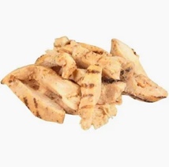  Grilled chicken | 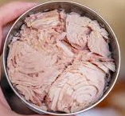  Tuna | 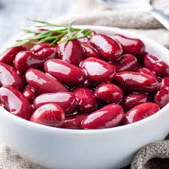  Beans | 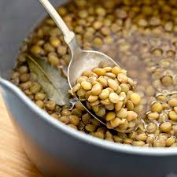  Lentil | 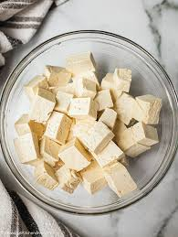  Tufo | 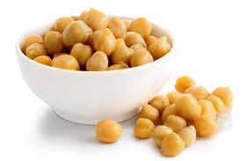  Check peas
Vegetables | 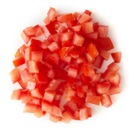 | 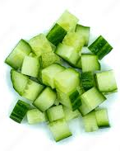 | 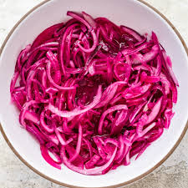 | Mushrooms  Cucumber  Tomato, | Bell pepper  Asparagus  onion  summer squash
DRESSING | 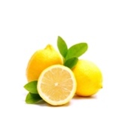 | 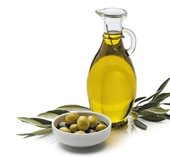 | 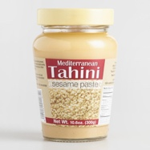 | 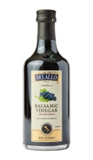 | Pomegrant mollasses | yougurt

