Health Related Report on the Prevalence of Poor Diet and Related Conditions Among Workers in Scranton (Lackawanna County)

Introduction/Background
This health-related report focuses on the prevalence of poor dietary habits and their associated health conditions among workers in Scranton, Lackawanna County. Data from the Behavioral Risk Factor Surveillance System (BRFSS) highlight the impact of poor nutrition, obesity, and chronic disease. My target population is The Wright Center for Community Services, a regional hub for health services and medical training, which serves as the focal point of this analysis.
Health sector workers are frequently regarded as role models for health promotion and disease prevention, yet the occupational demands of their profession often place them at disproportionate risk for developing unhealthy eating behaviors. Long shifts, unpredictable schedules, high stress levels, and inadequate time for meal preparation contribute to dietary patterns characterized by meal skipping, reliance on convenience foods, and frequent consumption of fast food (Phiri et al., 2021; World Health Organization (WHO) , 2020). For example, research indicates that up to 60% of hospital staff on night shifts report skipping meals, while those who do eat during work hours often choose calorie-dense, nutrient-poor options available in vending machines or nearby fast-food outlets (Phiri et al., 2021).
Over time, these patterns of behavior are strongly associated with adverse health outcomes, including obesity, hypertension, and hyperlipidemia (high cholesterol). The Behavioral Risk Factor Surveillance System (BRFSS) provides local data illustrating the scope of the problem in Lackawanna County, Pennsylvania, where approximately 33% of adults report obesity, nearly one in four have hypertension, and 14% report high cholesterol (Pennsylvania Department of Health, 2021). These findings align with national data; according to the Centers for Disease Control and Prevention (CDC, 2022), obesity prevalence among U.S. adults has reached 42%, and hypertension affects nearly half of the adult population. Both conditions are among the strongest modifiable risk factors for cardiovascular disease, the leading cause of death in the United States (Benjamin et al., 2019).
Moreover, healthcare workers are uniquely positioned within this landscape. Their credibility as promoters of health and wellness is undermined if their own health behaviors do not align with the recommendations they provide to patients (Zheng et al., 2019). This creates a dual burden: not only are their personal health outcomes compromised, but their ability to effectively model healthy behaviors is diminished. The evidence underscores the need for targeted interventions that address the barriers healthcare workers face in adopting and sustaining healthier eating practices.
This report therefore aims to quantify the burden of poor dietary habits among Scranton-area healthcare workers using BRFSS data, while also outlining resources and strategies that can mitigate these risks. Evidence-based recommendations will be provided, with a focus on workplace nutrition education, culturally sensitive interventions for international staff, and organizational policy changes that enable healthier food choices within the healthcare setting.

Summary of Existing Data
BRFSS data and local community health assessments provide evidence of significant health challenges among workers.
- Obesity (BMI ≥ 30): Approximately 33% of adults report obesity, aligning with state and national concerns as shown in graph (1).
- Hypertension: Around 23% of adults report being diagnosed with high blood pressure. Graph (3)
- High Cholesterol: Approximately 14% of adults report elevated cholesterol levels. Graph (3)
- Fair or Poor Health: Between 10–14% of adults rate their health as fair or poor. Graph (2)
- Preventive Care Gaps: Nearly 30% reported no routine health check-up in the past year, and roughly 25% do not have a regular healthcare provider.
These findings reveal a high prevalence of preventable chronic conditions, driven largely by poor lifestyle choices such as unhealthy diets, physical inactivity, and stress. The combination of health risks and healthcare access barriers creates a concerning public health scenario for Scranton workers.
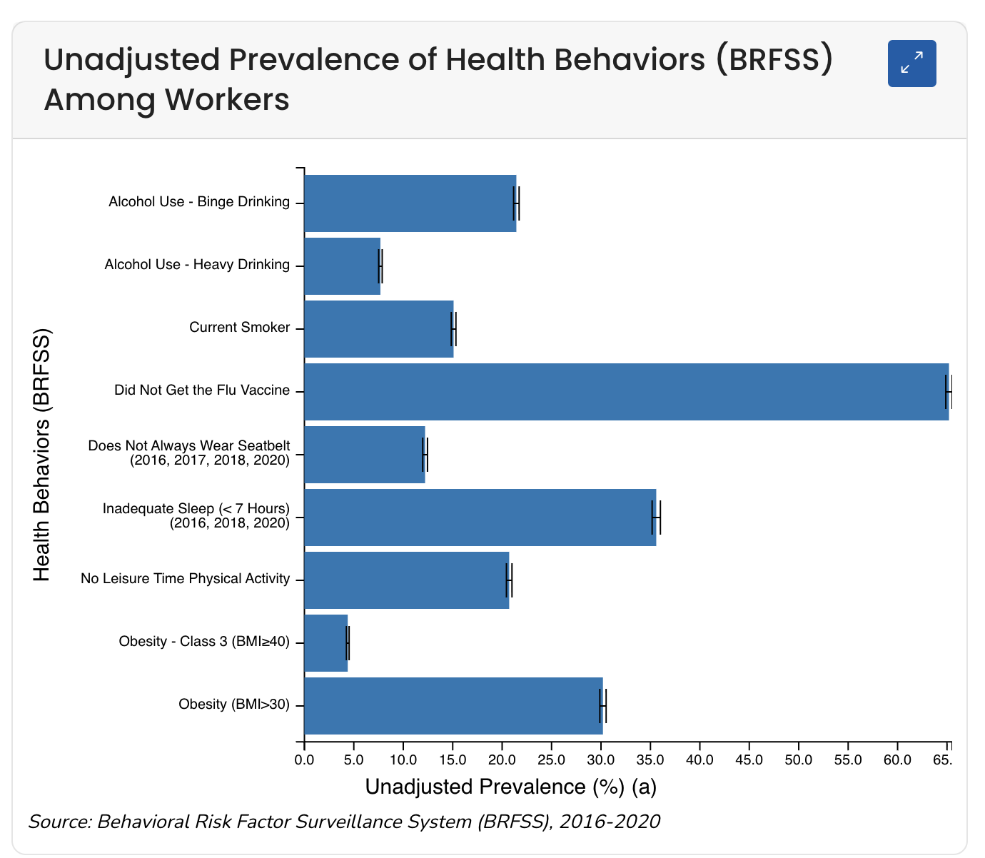
Graph (1)
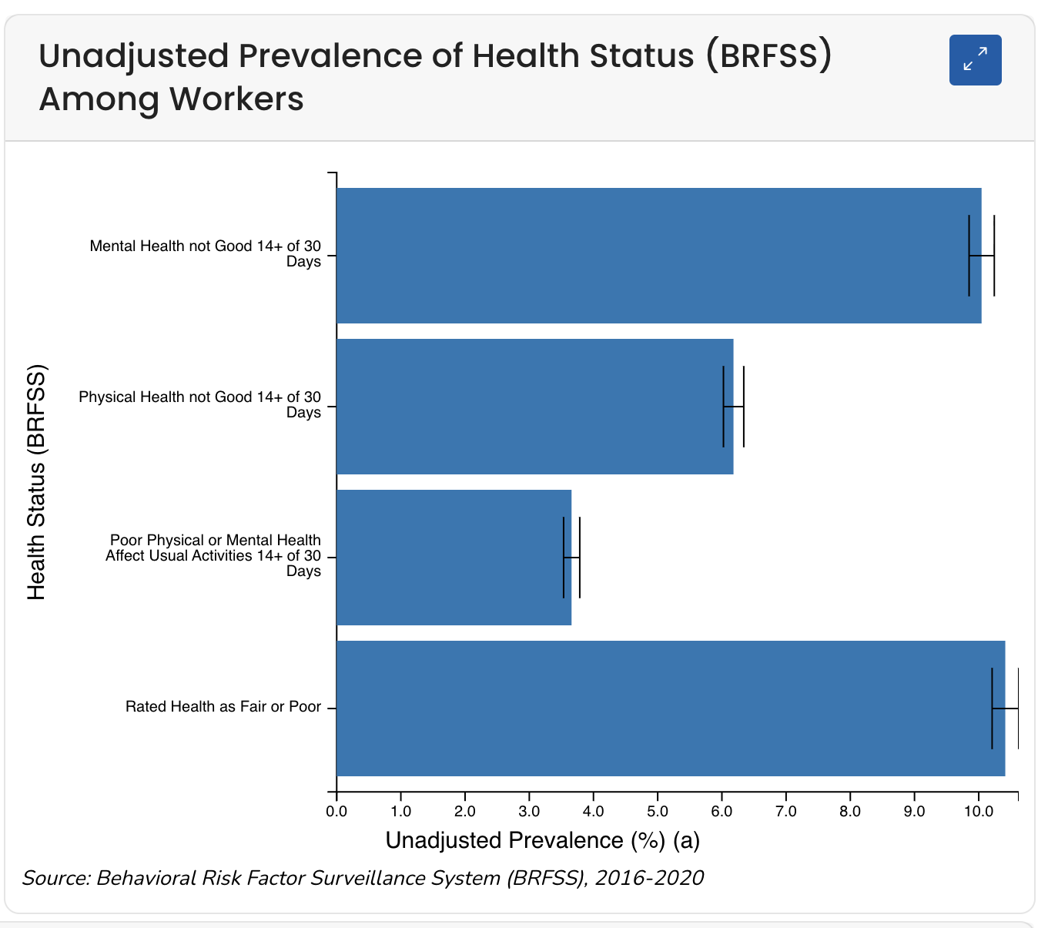

Graph (2)
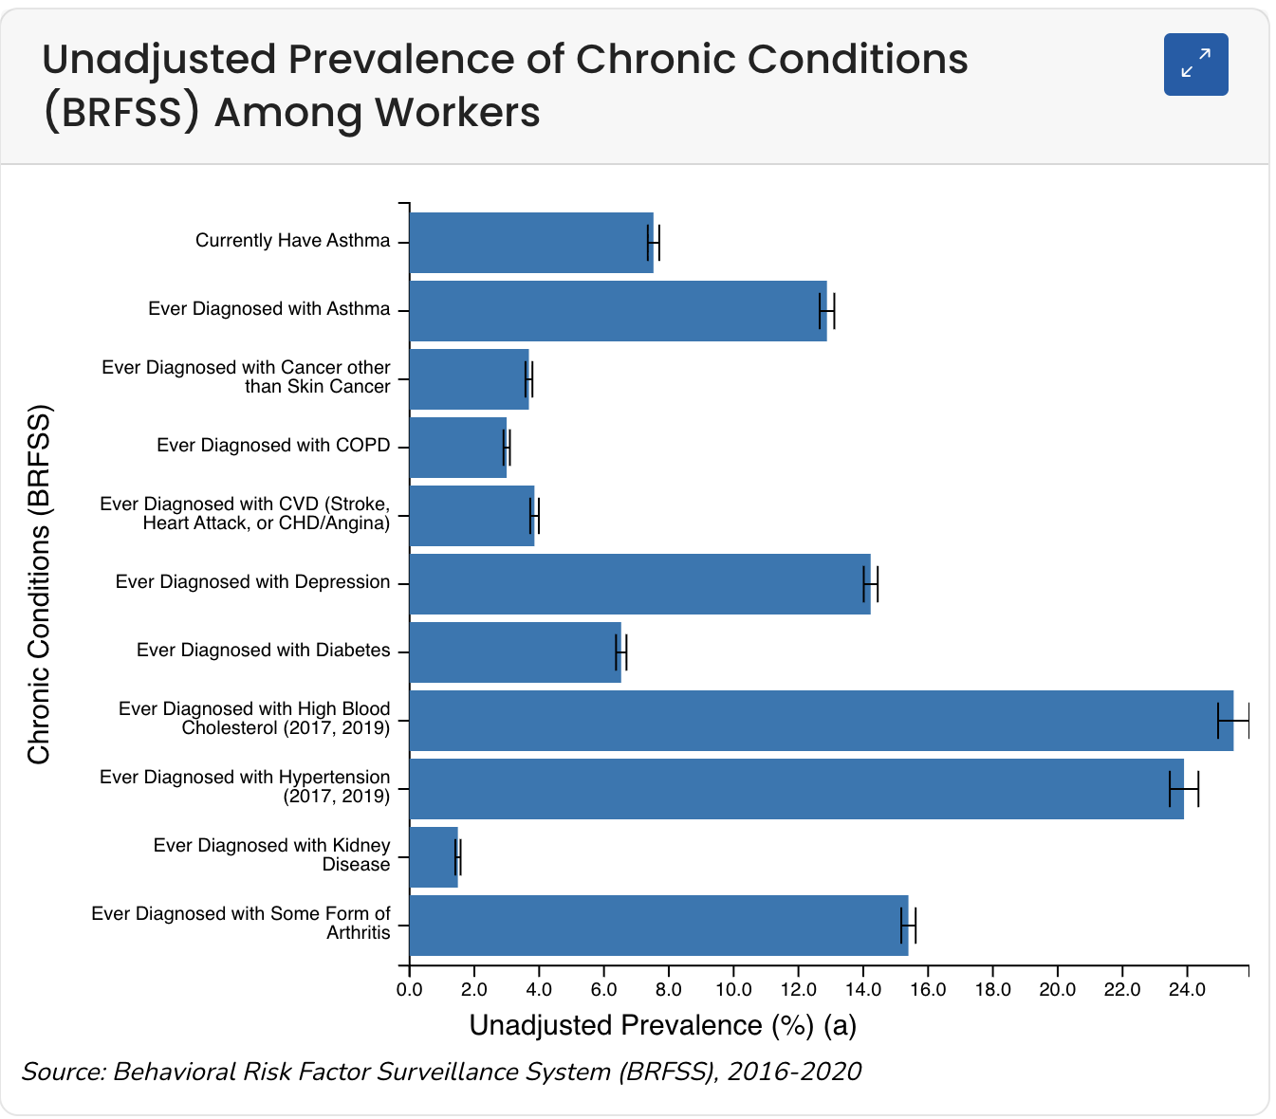

Graph (3)
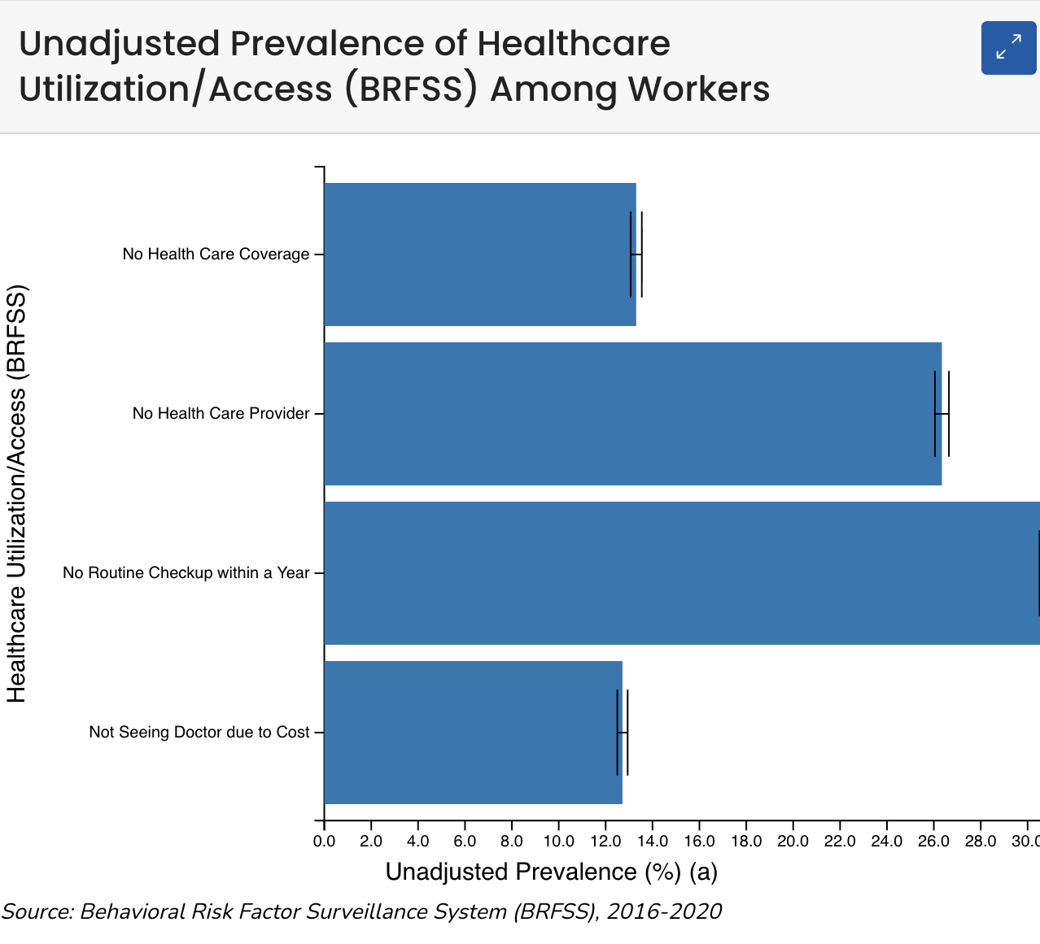
Graph (4)

Demographics
Scranton is the largest city in Lackawanna County, with a population of approximately 216,000. The workforce includes a substantial number of healthcare workers, students, and residents at The Wright Center for Community Services. Importantly, many of these residents are international medical graduates who are newly exposed to American fast-food culture. This cultural adjustment, combined with heavy workloads and financial constraints, increases the risk of adopting unhealthy eating patterns.
The diversity within this workforce presents both challenges and opportunities. On one hand, international staff may lack familiarity with local food systems and nutritional labeling, leading to reliance on fast food. On the other hand, their varied backgrounds allow health promotion efforts to incorporate culturally diverse dietary practices and recipes, making interventions more inclusive and relevant.

Problem Description
Poor diet and unhealthy eating patterns are among the leading contributors to chronic disease in the Scranton workforce. Workers, particularly in the health sector, often face long working hours that leave little time for proper meal planning or preparation. As a result, many workers rely heavily on fast food, processed meals, or snacks high in sugar, salt, and fat. This dietary pattern is a primary driver of obesity and related metabolic conditions.
Obesity itself is not merely a cosmetic issue; it is a serious health condition associated with higher risks of heart disease, stroke, type 2 diabetes, and some cancers. The BRFSS data show that nearly one in three adults in the county is obese, placing a significant burden on healthcare resources and reducing productivity among workers. In a healthcare environment such as The Wright Center, these patterns are especially concerning, as healthcare professionals are simultaneously providers of care and at risk themselves.
Hypertension, reported in nearly 23% of the workforce, is another major problem linked to poor diet. High sodium intake, which is common in fast food and processed meals, directly increases blood pressure levels. Over time, hypertension contributes to cardiovascular disease, kidney failure, and premature mortality. Combined with obesity, hypertension creates a dangerous cycle of chronic illness.
High cholesterol prevalence, at 14%, further reflects unhealthy eating habits. Diets rich in trans fats, fried foods, and red meat are strongly associated with hyperlipidemia. Elevated cholesterol, in turn, increases the risk of atherosclerosis and coronary heart disease. When coupled with a lack of physical activity, another issue identified by BRFSS data, workers face a compounding risk of cardiovascular events.
The problem is exacerbated by limited healthcare engagement. Nearly one in four workers does not have a healthcare provider, and 30% report skipping preventive check-ups. Without access to early detection and counseling, many individuals remain unaware of their conditions until they progress to more severe stages. This highlights the importance of workplace health promotion as a primary prevention strategy. In this context, prevention is more effective and less costly than treatment.
Adding to the challenge, many workers rate their health as fair or poor. This self-assessment reflects both physical and mental health challenges, likely worsened by demanding schedules, stress, and lack of time for self-care. The culture of neglecting personal health to prioritize work responsibilities is deeply ingrained, especially in healthcare settings, and must be addressed.

Community Resources
Scranton and Lackawanna County are home to several resources that can be leveraged to address poor diet and its health impacts. The Wright Center itself offers a unique platform, with training programs for medical students and residents. By integrating nutrition education into these programs, future healthcare providers can both improve their own health and become advocates for patient wellness. Community-based organizations, local grocery stores, and health coalitions can also partner in providing budget-friendly food access, cooking demonstrations, and culturally inclusive nutrition materials.

Recommendations
For this project I prepared educational plan for workers at the Wright center, which will help them manage and change their eating habits, and make food preparation easier for them, the project includes the following :
1. Nutrition Education Workshops: Offer targeted workshops for workers that focus on:
- Meal planning with affordable ingredients
- Easy, quick-to-prepare recipes suitable for busy schedules
- Grocery list examples and preparation strategies
- International recipes to reflect workforce diversity
2. Comprehensive Nutrition Manuals: Provide accessible manuals and lectures that include:
- MyPlate guidelines and food group definitions
- Recommended daily servings and portion sizes
- Benefits of balanced eating patterns
- Step-by-step guidance on meal preparation
3. Preventive Healthcare Access: Encourage routine screenings, provide incentives for check-ups, and facilitate connections with primary care providers for workers without established healthcare relationships.
By addressing both individual behavior and systemic workplace factors, these recommendations aim to reduce the prevalence of obesity, hypertension, and high cholesterol in Scranton’s workforce.

References
Benjamin, E. J., Muntner, P., Alonso, A., Bittencourt, M. S., Callaway, C. W., Carson, A. P., Chamberlain, A. M., Chang, A. R., Cheng, S., Das, S. R., … Virani, S. S. (2019). Heart disease and stroke statistics—2019 update: A report from the American Heart Association. Circulation, 139(10), e56–e528. https://doi.org/10.1161/CIR.0000000000000659
Centers for Disease Control and Prevention. (2022). Adult obesity facts. U.S. Department of Health and Human Services. https://www.cdc.gov/obesity/data/adult.html
Centers for Disease Control and Prevention. (2022). Behavioral Risk Factor Surveillance System (BRFSS). U.S. Department of Health and Human Services. https://www.cdc.gov/brfss
DataUSA. (2022). Lackawanna County, PA demographics. Deloitte, Datawheel, & MIT Media Lab. https://datausa.io/profile/geo/lackawanna-county-pa
Lehigh Valley Health Network. (2022). Lackawanna County community health needs assessment 2022. https://www.lvhn.org
Novo Nordisk. (2021). State of obesity and chronic disease report: Pennsylvania. Novo Nordisk Works. https://www.novonordiskworks.com
Pennsylvania Department of Health. (2021). Chronic disease burden report. Harrisburg, PA.
Pennsylvania Department of Health. (2021). County health profiles and chronic disease burden report. Commonwealth of Pennsylvania. https://www.health.pa.gov
Phiri, L. P., Draper, C. E., Lambert, E. V., & Kolbe-Alexander, T. L. (2021). Nurses’ lifestyle behaviours, health priorities and barriers to living a healthy lifestyle: A qualitative descriptive study. BMC Nursing, 20, 164. https://doi.org/10.1186/s12912-021-00680-2
PubMed. (n.d.). Diet-related chronic disease research. U.S. National Library of Medicine. https://pubmed.ncbi.nlm.nih.gov
ScienceDirect. (n.d.). Diet-related chronic diseases. Elsevier. https://www.sciencedirect.com
World Health Organization. (2020). Healthy diet. https://www.who.int/news-room/fact-sheets/detail/healthy-diet
Zheng, C., Chen, J., & Chen, L. (2019). Health behaviors and occupational burnout among healthcare workers: The mediating role of self-efficacy. Frontiers in Public Health, 7, 190. https://doi.org/10.3389/fpubh.2019.00190

