Human Resources Outline
Module 7
Answer the following questions and place the completed outline in your portfolio.
I had an intervew Elaine Evans the HR for Aramrk at scraton area, and went throw all the outline with her
Recruitment:
• How do the Human Resources recruit new employees?
If a department in demand or shortage with workers they contact the Human recouces department, and the HR manager will creat job requisition, Aramark's Human Resources recruits new employees by posting job openings on their website ( internally) , utilizing a virtual recruiting assistant called Allie, attending hiring events, and leveraging professional networks and partnerships with educational institutions.
they do monitor the requisition to reach out to candidiate , then using internal system ( my work life) the candidate will be moving throut a series of steps
The hiring process involves submitting an application, a recruiter review, interviews, and background checks, with options for text message communication and the use of a dedicated virtual assistant to streamline the process.
They use internal program that pulls all the background for the candidates to see if the meet the requirements or not.
• What media are used to advertise job openings?
They announce the position internally first on Aramark website then it is posted externally for example ( Indeed, IFMA.. etc.) , news letter and flyers with QR codes and they use social media pages of Aramark.
• What are the costs of recruitment?
It depen on the position if they cannot find a suitable candidate using their internal advertisement, they will use advertising, agency which will give them a price for advertizing package, other expences will be soft costs like the salaries of internal recruiters and the time managers spend on the hiring process.
• How many people are usually interviewed before a position is filled?
they keep interveing unitill one candidate meets the requirments , sometimes they have 10 – 12 positions open at the same time.
Job Description
• What format is used in the facility?
internal advertisment of the job discriptoin followed by external advertisment
I am attaching ( wharehouse worker ) job announcment found at Aramark website including a job discription
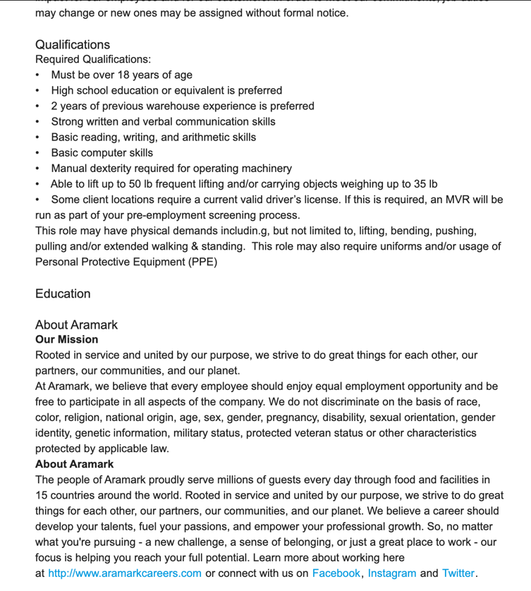
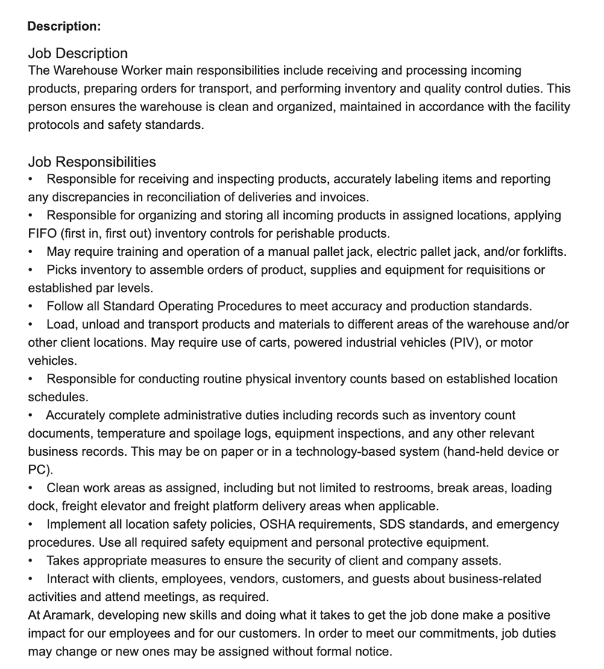
• What are the criteria-based job descriptions?
They include the job discription in the requisition, and when they annonce the open position, but once hierd, or during the intervew they will have intinsive discription
• Update or develop a job description for a position as suggested by your preceptor.
I updated food describtion for Food Service Manager at Aramark website
Requisition #: 601965 , you may find it at the end of this outline

Performance Appraisals
• Who determines the standards for evaluating the performance of current employees?
all current employees at Aramark have (union account) which desplays the progress of each employee and if they meet the goals and the expectation that they are required to meet, and it shows if they violate the policies of Aramark
It also show their Attendace.
• How similar is the performance appraisal to the job description?
Mostley the same, as the appraisal directly evaluates an employee's performance against the duties, responsibilities, and expectations outlined in their job description.
• Observe a performance appraisal session if possible (Schedule in
advance).

Not available
Grievances
• What is the policy regarding grievances?
A grievance is an alleged violation as to the meaning, interpretation or application of any of the provisions of this Agreement. There shall wherever practical be an attempt by the parties to resolve grievances informally prior to filling a written grievance.
• How are grievances handled?
Step I.
If the informal attempt fails to solve the alleged violation, the Union
shall, within five (5) days from the time it knew or should have known, reduce it to writing and forward it to the Food Service Director, who shall within five (5) working days after receiving the grievance schedule a conference for the purpose of resolving the alleged violation. The aggrieved employee and a representative of the Union shall be present at the conference. Within five (5) working days from the date of the conference, a written reply on behalf of the Employer shall be issued through the office of the Food Service Director to the aggrieved employee with a copy to the Union.
Step II.
If the reply given at Step I is unsatisfactory, the Union shall submit the
grievance to the Company's District Manager.
Step III.
If the decision given at Step Il unsatisfactory, the Union shall within
five (5) days from the receipt of that decision, file a written request with the Human Resources Director for a review of the decision given under Step II. The said review
shall be granted or denied within fifteen (15) working days from receipt of the request. The Company will provide a written decision within ten (10) days from the day on which the Human Resources Director heard and reviewed the case.
Step IV.
Failing a satisfactory settlement of the grievance at Step Ill, the matter
may be referred by the Union to arbitration within thirty (30) days of the receipt of the Company's written answer at Step III.
• What is the role of the food service manager in a grievance placed by a food service worker? Personnel Actions
The FSM works closely with HR, LR to come to a resolution.
If the informal attempt fails to solve the alleged violation, the Union
shall, within five (5) days from the time it knew or should have known, reduce it to writing and forward it to the Food Service Director, who shall within five (5) working days after receiving the grievance schedule a conference for the purpose of resolving the alleged violation. The aggrieved employee and a representative of the Union shall be present at the conference. Within five (5) working days from the date of the conference, a written reply on behalf of the Employer shall be issued through the office of the Food Service Director to the aggrieved employee with a copy to the Union.
• Are promotions / demotions based on the performance appraisals?
Not entirely. There are many components that go into the decosion making process. Experience, Eduction, performance issues etc
• Are promotions / demotions reviewed and acted upon by HR or by the food service manager?
For hourly It is a union account so there is specific guidelines for the bidding process
• Review the procedures required to place an employee on probation /
warning level, and/or to terminate. Summarize this procedure and indicate when the department manger is involved.
Professional Training
Salary employees are placed on PIP with specific guidelines to improve job performance withen a specific time typically no longer than 90 days. Once copleted if termination is warranted employement is severd
• What credentials does the facility require for its professional staff?
Servesafe
they have a process of goals that are created and are completed . also it s the responsibility of the RD to make sure she/he has her CEPs up to date as well as their certifications.
• How is maintenance of credentials documented?
Self Monitored and submitted to the account for records
• Is there a professional educational plan in place for the R.D.?
Must foloow the guidelines set forth by CDR
75 CPEUs every 5 years
Maintain licensure for state of PA
• Is there in-house staff development?
They have training Modules that must be completed annually.

Job discribtion Changes ( Modification)
Title: Food Service Manager
Requisition #: 601965
Location:
Scranton, PA, US, 18505-1215
Career Area: Food Service
Description:

Job Description
The Food Service Manager is a management position responsible for developing and implementing dining solutions to meet customer needs and tastes. Oversees and manages dining operations where customers order prepared foods from a menu.
Aramark Student Nutrition provides food and nutrition services to over 350 school districts in the U.S. It offers public and private education institutions a variety of dining options including breakfast and lunch programs, after-school snacks, catering, nutrition education and retail operations. We partner with schools to create culinary experiences that propel students to success. Our goal is to provide healthy, nutritional meals with a stellar dining experience for our communities. For more information on Aramark's Student Nutrition food service programs, please visit Aramark Student Nutrition.

Job Responsibilities
Leadership
- Use Aramark's coaching model to engage and develop team members to their fullest potential
- Reward and recognize employees
- Ensure individual and team performance meets objectives and client expectations
- Plan and lead daily team briefings
- Ensure safety and sanitation standards in all operations
Client Relationship
- Identify client needs and communicate operational progress
Financial Performance
- Ensure the completion and maintenance of P&L statements
- Deliver client and company financial targets
- Adopt all Aramark processes and systems, understand performance metrics, data, order and inventory trends; educate teams on key levers to improve margins
Productivity
- Bring value through efficient operations, appropriate cost controls, and profit management
- Follow the Operational Excellence fundamentals by meeting and maintaining food and labor initiatives
- Ensure entire team is trained and able to implement
- Supervise team regarding production, quality and control
Compliance
- Maintain a safe and healthy environment for clients, customers and employees
- Follow all applicable policies, rules and regulations, including but not limited to those relating to safety, health, wage and hour
Additional Responsibilities
- Lead the front of the house of the dining operation (Cafeteria/ Residential Dining Facility) in conjunction with the Food Service Director
- Plans, directs, and coordinates food service activities in order to deliver a finished product to the customer
At Aramark, developing new skills and doing what it takes to get the job done make a positive impact for our employees and for our customers. In order to meet our commitments, job duties may change or new ones may be assigned without formal notice.

Qualifications
- Requires at least 1 year of experience
- Requires at least 1 year of experience in a management role
- Strong interpersonal skills
- Bachelors Degree Preferred ( must be required Bachelor degree in Nutrition)
- Serv Safe Certified Preferred
- Ability to work in a fast paced environment
- Nutrition Background and/or strong understanding
- Ability to maintain effective client and customer rapport for mutually beneficial business relationships
- Ability to demonstrate excellent customer service using Aramark's standard service model
- Ability to maintain an effective working relationship with other departments to a unified food service experience for all customers
- Requires occasional lifting, carrying, pushing, and pulling up to 50 lb.
- Must be able to stand for extended periods of time.
- Add ( good computer skills because they use more than one computer system)

Education

About Aramark
Our Mission
Rooted in service and united by our purpose, we strive to do great things for each other, our partners, our communities, and our planet.
At Aramark, we believe that every employee should enjoy equal employment opportunity and be free to participate in all aspects of the company. We do not discriminate on the basis of race, color, religion, national origin, age, sex, gender, pregnancy, disability, sexual orientation, gender identity, genetic information, military status, protected veteran status or other characteristics protected by applicable law.
About Aramark
The people of Aramark proudly serve millions of guests every day through food and facilities in 15 countries around the world. Rooted in service and united by our purpose, we strive to do great things for each other, our partners, our communities, and our planet. We believe a career should develop your talents, fuel your passions, and empower your professional growth. So, no matter what you're pursuing - a new challenge, a sense of belonging, or just a great place to work - our focus is helping you reach your full potential. Learn more about working here

