Orientation to Department and Facility Aramark K-12 Student Nutrition Program, school distric
(South Scranton Intermediate School)

Orientation to Department
Introduction to Management, Supervisory Staff, and Staff
The Aramark Food Service Department operates under a structured management hierarchy. The General Manager oversees all food operations for 17 schools in the Scranton district, supported by the Food Service Director and Production Manager, who handle procurement, daily purchasing, and logistics.
Supervisory staff include kitchen leads in each production school and supervisors who ensure compliance with safety, sanitation, and operational standards. There are 127 employees across the network, including chefs, cooks, dietitian, and service aides.
Daily communication occurs through direct meetings and digital channels (e.g., a WhatsApp group) for scheduling, updates, and feedback.
Department Tour and Flow of Materials
The operational flow follows HACCP standards and includes five subsystems:
- Receiving Area: Dedicated dock with temperature checks and inspection logs; deliveries are verified and labeled upon arrival.
- Storage Areas: Segregated for dry goods, refrigeration, frozen, disposables, and chemicals. Temperature logs are completed three times daily, and all storage follows FIFO rotation.
- Preparation Area: Stainless-steel workstations for washing, chopping, and cooking; includes commercial ovens, tilting skillets, and high-capacity mixers.
- Service Area: Offers multi-line service for student efficiency, including hot meals, grab-and-go options, and salad bars.
- Sanitation Area: Includes sinks, dishwashing equipment, and waste segregation systems; all staff are trained in HACCP sanitation and safety standards
Definition of Production Areas
- Cold Area: Includes walk-in coolers and refrigerators for chilled foods.
- Cook’s Area: Contains ovens, skillets, and steam tables for large-volume production.
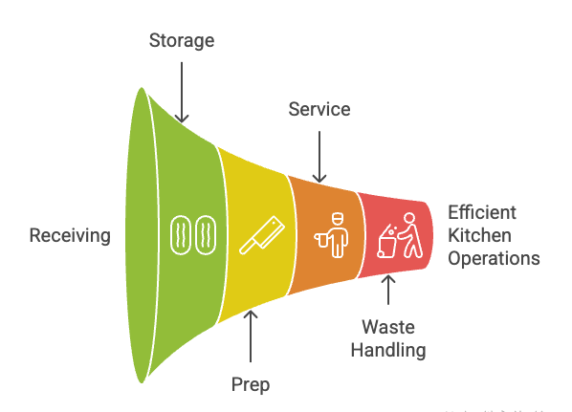
- Preparation Stations: Separated by task (washing, cutting, assembling) to ensure safety and efficiency.
The layout allows a smooth linear workflow

Special Qualities of Employees
Employees demonstrate strong teamwork, food safety knowledge, and bilingual communication (notably English and Spanish). Many hold ServSafe certification, and supervisory staff possess management, nutrition, and HACCP credentials. Staff show high stability, with cross-training to ensure flexibility during absences or high-volume periods
Hours of Operation
The department operates approximately 8 hours per day across 5 days per Week, totaling around 41 productive hours per week. Production begins early to accommodate breakfast and lunch for both on-site and satellite schools
Description of Department
Aramark employs a hybrid cook/chill and speed-scratch production model. Meals are prepared in bulk at production schools, chilled, and delivered to satellite schools for reheating.
Equipment varies in age walk-ins and ventilation are older but well-maintained; newer items include energy-efficient combination ovens and POS systems.
Technology integration includes the BirchStreet System for procurement and inventory, and POS systems for student accounts and compliance tracking
Menu System
Menus follow a five-week cycle, updated regularly.
Reviews occur weekly and monthly to maintain variety and student engagement. (Pop-up) menu items are introduced during special events or holidays (e.g., Christmas, fall season). Menu changes are driven by student feedback, cost trends, and USDA nutrition requirements

Orientation to Facility

Organizational Chart & Contract Overview
The Food Service Director reports to the General Manager, who oversees all K-12 operations under the Aramark corporate structure.
The Scranton School District maintains a five-year contract with Aramark, which outlines performance standards, menu compliance, staffing, and reporting obligations.
Aramark handles procurement, production, and service under this management contract
Mission and Long-Range Plans
Mission Statement:
“Rooted in service and united by our purpose, we strive to do great things for each other, our partners, our communities, and our planet.”
For the school lunch program, the mission is to support education by providing high-quality, nutritious, and appealing meals that fuel academic success.
Long-range plans include expanding digital systems, improving menu variety, and continuing nutrition education through programs like Smart Partners (fresh fruits and vegetables program with educational flyers)
Inspections and Surveys
The Pennsylvania Department of Agriculture conducts biannual inspections March and October focusing on safety and sanitation.
Additionally, Steritech Audits occur annually, and internal HACCP reviews are ongoing.
The next Joint Commission-type audit is scheduled for October, with the last completed in January.
The facility follows Chapter 23 of the Pennsylvania Administrative Code, reviewed every five years, ensuring compliance with state health regulations
Summary
The Aramark K-12 Food Service Department exemplifies a comprehensive, technology-enabled, and safety-driven operation.
From structured vendor management and HACCP-based receiving systems to bilingual, well-trained staff and nutrition-focused menu innovation, the department effectively balances operational efficiency with educational mission goals.

