Manual Analysis
For this project, I had a discussion with the RD at Aramark and she said they don’t have special menus with low Cholesterol, Sodium or controlled CHO, as they follow regulation sent forth by the USADA. Special Menus are created on per-case basis All the bread used for sandwiches is whole grain, they limit added sugars, according to federal regulation and they have Lactose free milk for kids with lactose intolerance.
They Follow us USDA school nutrition guidelines for all meals and even snacks sold at ALA cart they check each and every item in the ALA cart station using this website to insure compliance, on the other hand they use USAD ( A guide to Smart Snacks in School) and I am attaching a picture as an example from this manual.
USDA Sodium limit for school lunch and breakfast.
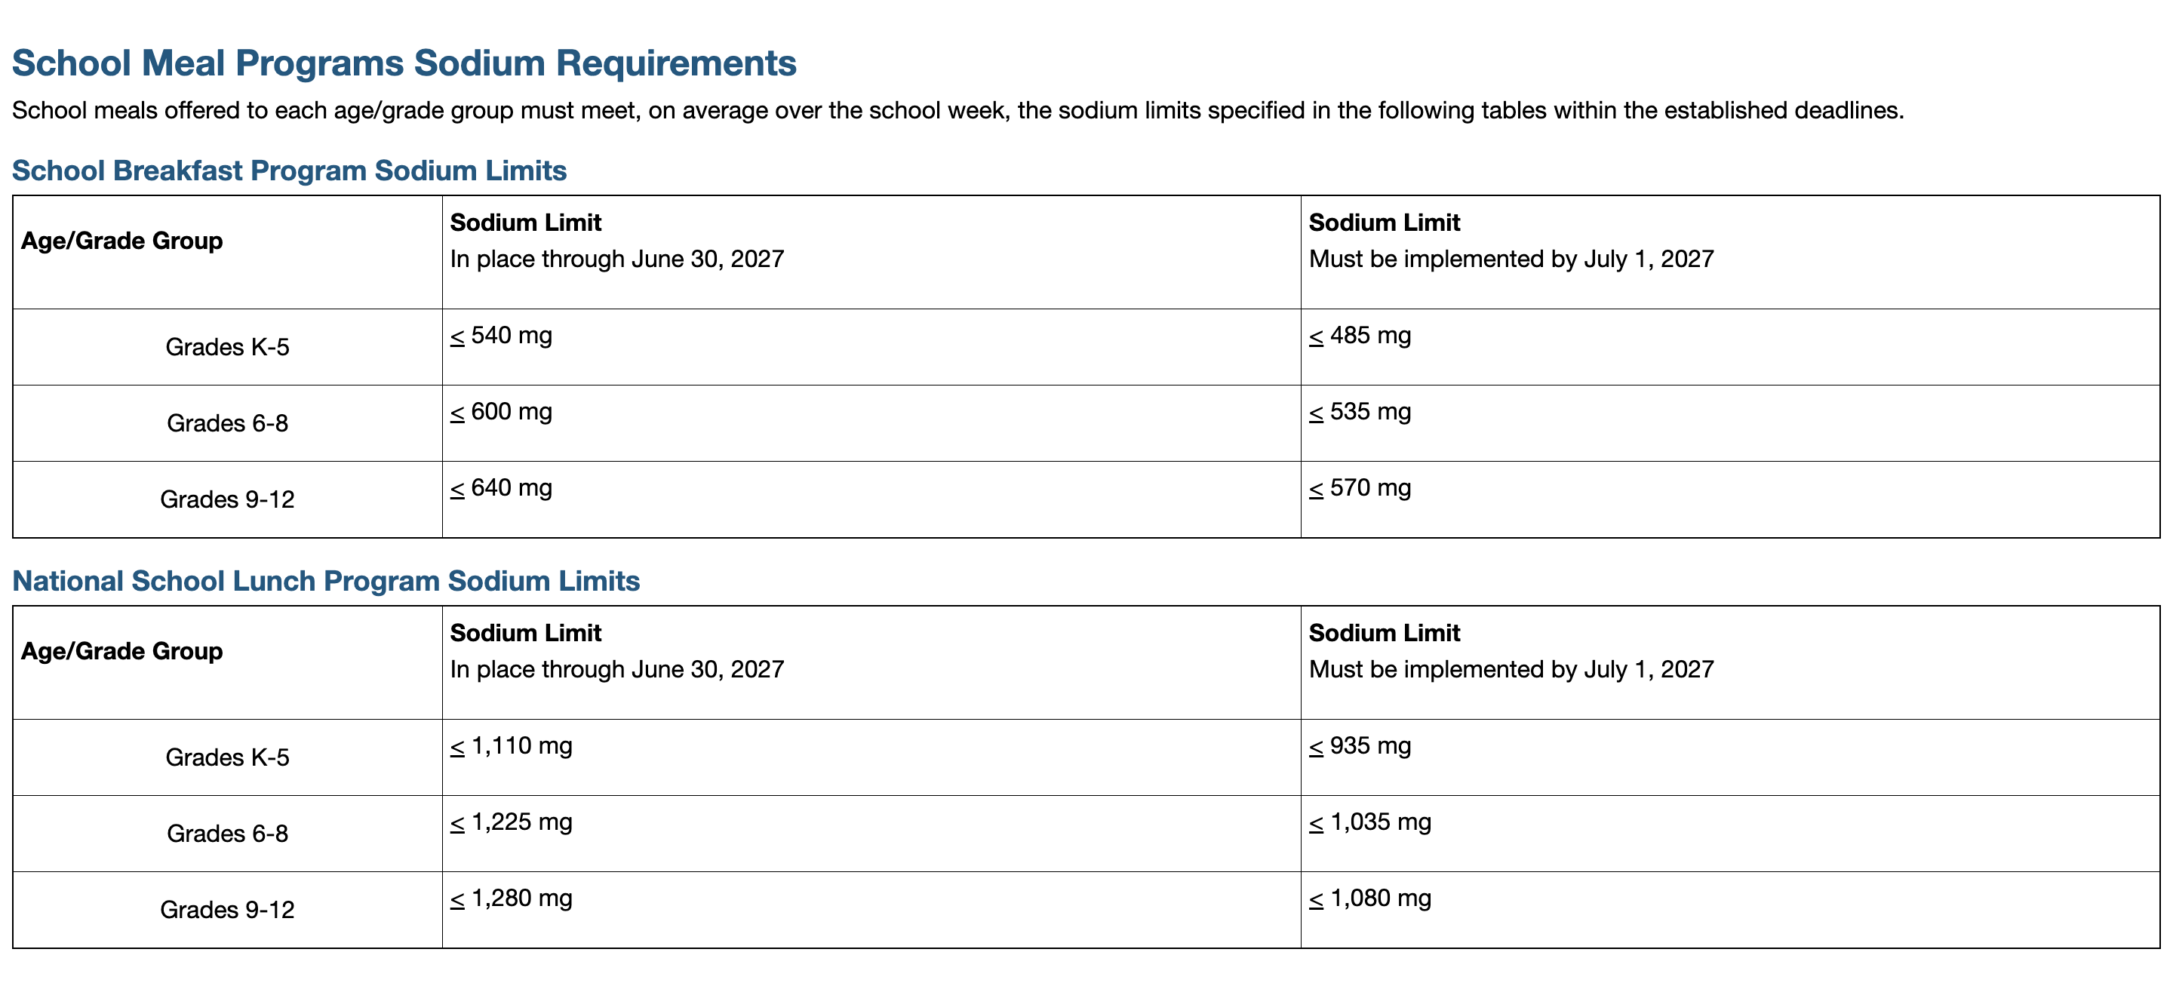
USDA recommendation from each food group for all student ages per Week for lunches
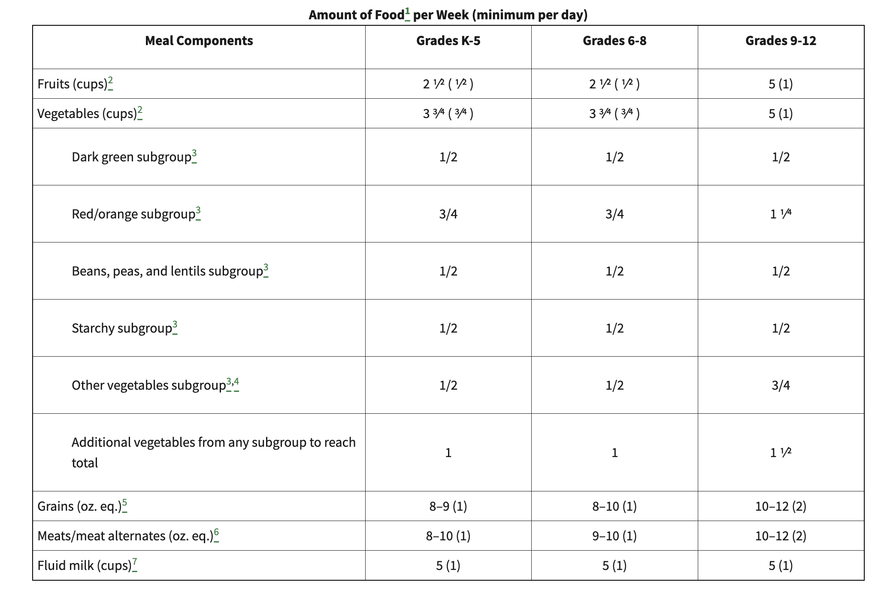
All the students have more than one choice for their lunch meal and can create their own special meal to be low in sodium or fat or controlled CHO. So I only created meal using the regular menu to choose the appropriate choice that fits each special diet requirements. For example:
• Cheese-heavy sandwiches and processed meats (ham, hot dogs) drive sodium above 1,000 mg per entrée. Use low-sodium deli meats, reduce cheese to 1 slice (28 g), and choose whole fruits over juice to lower sodium while maintaining nutrition.
• For CHO control, pair sandwiches/buns with non-starchy vegetables and whole fruits; avoid tater tots and juice. Aim for 45–60 g CHO per meal by limiting bread to one 2-slice serving and selecting fruit cups (18–22 g CHO).
• To keep cholesterol ≤200 mg/day, lean/plant proteins (PB&J, beans) and egg portions ≤2 oz help. Limit cheese and breaded/fried items; when serving burgers or chicken patties, use low-fat cheese or omit cheese.
On the other hand created a 5 day Gluten Free menu for kids, so they can give it to parents of kids with Celiac or Gluten Allergy, my Preceptor ( ALehea) suggested if we create this menu it will be helpful because they started to see an increasing number of students with Celiac or Gluten sensitivity.

(manual analysis using USDA/K–12 reference portions).
Manual analysis for food items in lunch menu at south Scranton intermediate school in September, I chose 3 days to do (Monday, Tuesday, Wednesday)
Regular diet menu:
Day: Monday
# | Entrée | Kcal | Protein | Carbs | Fat | Chol | Sodium
1 | Beef Soft Tacos (2) | 520 | 33 | 36 | 27.0 | 100 | 975
2 | Corn Dog | 240 | 7 | 30 | 10.0 | 35 | 700
3 | Ham & Cheese Sandwich | 380 | 28 | 28 | 17.0 | 80 | 1860
4 | PB&J | 400 | 14 | 49 | 18.0 | 0 | 415
5 | Cheese Sandwich | 440 | 21 | 29 | 27.0 | 75 | 1760
Sides available:
Vegetables: Kickin' pintos, 4 oz, Tomato wedges, 4 oz, Garden salad, 1 cup
Fruits: Mixed fruit, 4 oz (cup), 100% juice, 4 oz
Day: Tuesday
# | Entrée | Kcal | Protein | Carbs | Fat | Chol | Sodium
1 | Bosco Sticks w/ Sauce | 350 | 16 | 44 | 12.0 | 30 | 900
2 | Cheeseburger | 380 | 24 | 23 | 20.0 | 85 | 595
3 | Italian Salad + Roll (ham/pepperoni/cheese) | 340 | 26 | 22 | 16.0 | 80 | 1750
4 | PB&J | 400 | 14 | 49 | 18.0 | 0 | 415
5 | Cheese Sandwich | 440 | 21 | 29 | 27.0 | 75 | 1760
Sides available:
Vegetables: Carrots, steamed, 4 oz, Cucumbers, 4 oz, Spinach salad, 1 cup
Fruits: Peaches, 4 oz (cup), Orange, medium
Day: Wednesday
# | Entrée | Kcal | Protein | Carbs | Fat | Chol | Sodium
1 | Mini Pancakes + Scrambled Eggs | 310 | 13 | 39 | 12.0 | 195 | 520
2 | Chicken Patty Sandwich | 330 | 18 | 34 | 12.0 | 45 | 680
3 | Ham & Cheese Sandwich | 380 | 28 | 28 | 17.0 | 80 | 1860
4 | PB&J | 400 | 14 | 49 | 18.0 | 0 | 415
5 | Cheese Sandwich | 440 | 21 | 29 | 27.0 | 75 | 1760
Sides available:
Vegetables: Tater tots, 4 oz, Celery, 4 oz, Garden salad, 1 cup
Fruits: Pears, 4 oz (cup), Apple slices, 4 oz
Therapeutic Diet Modifications
The following choices have been created using the choices in the regular menu to give an example of how we can choose from the varied option that they have in the menu to make low sodium choices or low cholesterol or controlled CHO choices
Modified Menu ( 2 g Sodium)
# | Day | Entrée | Vegetable | Fruit | Energy | Protein | Carbs | Fat | Chol | Sodium
1 | Monday | PB&J | Garden salad, 1 cup | Mixed fruit, 4 oz (cup) | 480 | 15.0 | 69.0 | 18.0 | 0 | 435
2 | Tuesday | Italian Salad + Roll (ham/pepperoni/cheese) | Cucumbers, 4 oz | Orange, medium | 418 | 28.0 | 41.0 | 17.0 | 80 | 1752
3 | Wednesday | Mini Pancakes + Scrambled Eggs | Garden salad, 1 cup | Apple slices, 4 oz | 380 | 14.0 | 57.0 | 12.0 | 195 | 536
Modified Menu (CHO-Controlled
# | Day | Entrée | Vegetable | Fruit | Energy | Protein | Carbs | Fat | Chol | Sodium
1 | Monday | Beef Soft Tacos (2) | Garden salad, 1 cup | Mixed fruit, 4 oz (cup) | 600 | 34.0 | 56.0 | 27.0 | 100 | 995
2 | Tuesday | Cheeseburger | Spinach salad, 1 cup | Orange, medium | 452 | 26.0 | 39.0 | 21.0 | 85 | 660
3 | Wednesday | Chicken Patty Sandwich | Garden salad, 1 cup | Apple slices, 4 oz | 400 | 19.0 | 52.0 | 13.0 | 45 | 696
Modified Menu (200 mg Cholesterol)
# | Day | Entrée | Vegetable | Fruit | Energy | Protein | Carbs | Fat | Chol | Sodium
1 | Monday | PB&J | Tomato wedges, 4 oz | Mixed fruit, 4 oz (cup) | 492 | 15.0 | 72.0 | 18.0 | 0 | 430
2 | Tuesday | Italian Salad + Roll (ham/pepperoni/cheese) | Cucumbers, 4 oz | Peaches, 4 oz (cup) | 426 | 28.0 | 44.0 | 17.0 | 80 | 1757
3 | Wednesday | Mini Pancakes + Scrambled Eggs | Celery, 4 oz | Pears, 4 oz (cup) | 400 | 14.0 | 62.0 | 12.0 | 195 | 605

Pictures from ( A guide to smart snacks in school )
