QM/PI Monitored to collect required data for customer satisfaction
In school food service management, the primary customers are the students. At the South Scranton Intermediate School Food Service Office, which oversees approximately 17 schools within the district including elementary, intermediate, and high schools continuous quality monitoring and performance improvement (QM/PI) are essential to ensure high levels of customer satisfaction. Gathering direct and indirect feedback from students helps the management team evaluate meal quality, menu appeal, and overall service effectiveness.
To capture students’ opinions about the meals and food items served, several strategies are used. One of the simplest yet most effective tools is the suggestion box placed in the dining area. This allows students to anonymously share their thoughts, complaints, and suggestions regarding the meals. This approach encourages honest feedback, especially from students who might hesitate to express their opinions directly to staff.

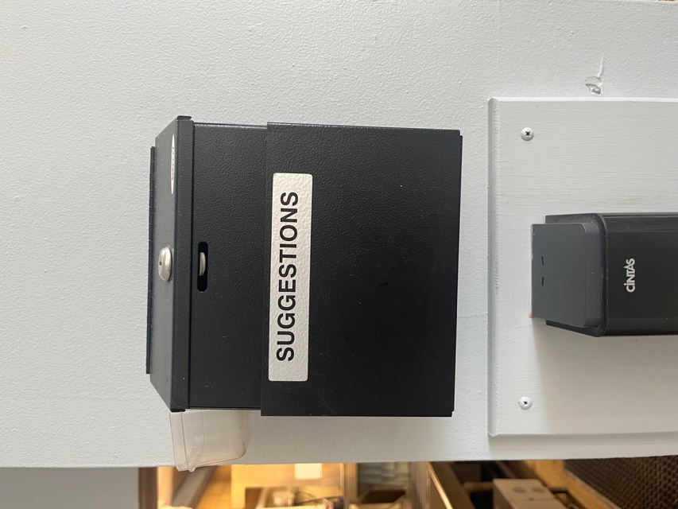

Another proactive method involves taste-testing and verbal feedback sessions whenever a new menu item is introduced. Before fully adding a new food item to the official menu, the office organizes “pop-up” or taste test days, where the item is temporarily featured and served to a sample group of students. During these events, food service workers and dietetic interns circulate among students in the cafeteria, asking about their opinions what they liked, disliked, and any suggestions for improvement. They also observe behavioral cues such as excitement, hesitation, or refusal to try the new item. These observations help determine whether the new product is suitable for permanent inclusion in the menu.
Examples of Feedback Collection Activities
During my rotation at this site, I had the opportunity to observe and participate in multiple activities that reflected active customer satisfaction monitoring. Examples included:
- Theme Meal Day
- Pretzels and Cheese Tasting Day
- Donut Sampling Day
- Apple Chips Trial Day
The Theme Meal Day was particularly well organized. The food service team promoted the special meal for an entire week before the event using posters, images, and menu boards displayed around the school. This visual communication helped students know what to expect and encouraged them to try the meal. Moreover, this form of advertisement allowed students to plan ahead either to participate in the special meal or bring lunch from home. This type of meal promotion not only boosts participation but also supports Aramark’s objective of ensuring that students receive two balanced meals daily.
On the day of the theme meal, students were provided with a taste evaluation form. Since this was an intermediate school, the form was designed to be easy to understand, using simple language and facial expressions (happy, neutral, and unhappy faces) to represent satisfaction levels. Students were encouraged to fill out the form during or after lunch. Each lunch period had about five students participating, providing a manageable but meaningful sample across four lunch periods. The data collected offered valuable insights into preferences and satisfaction trends
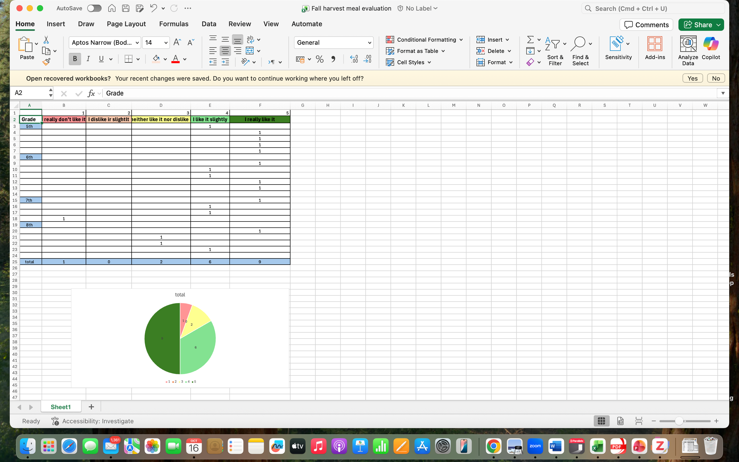

During Donuts and pretzels day the

In other schools, particularly elementary schools, a written evaluation method is less practical due to students’ young age and limited writing ability. Therefore, verbal evaluation is used instead. During tasting days such as the donut, pretzel, and apple chip trials staff and intern (Reem) interacted directly with students, asking short, clear questions about their opinions. For instance, during the donut tasting, students were offered two flavor options (plain and chocolate). Some preferred the plain flavor, while others favored chocolate; however, the overall acceptance rate was high since donuts are generally a popular food among children. And I was impressed how Aramark team was focusing on making the tasting table look nice and all the items on the table should look similar, nice and clean.
The verbal approach allowed for quick feedback collection during the short lunch periods and ensured that even the youngest students had a voice in the process. Observing their facial expressions, enthusiasm, and body language provided additional non-verbal data about the appeal of the food item.

Conclusion
In conclusion, the QM/PI monitoring system used by the South Scranton Intermediate School Food Service Office effectively integrates both quantitative (written surveys) and qualitative (verbal feedback and observation) methods to assess student satisfaction. These continuous feedback mechanisms not only ensure that meals meet nutritional and quality standards but also enhance student engagement and enjoyment. Such participatory evaluation fosters a sense of ownership among students, helping the food service team design menus that are both healthy and appealing, ultimately promoting better eating habits within the school community.

