In-Service Training Lesson Plan

The Big 9
Topic: Food Allergies: The “Big 9” and Cross-Contact Prevention
Presentation Tool: Prezi Presentation
Supplemental Materials: Flyer handout (The “Big 9” food allergens and cross-contact prevention)
Target Audience
ARAMARK food service workers at South Scranton School District.

Audience Characteristics
- Staff handle food preparation and service daily.
- Varying levels of education and training, but all are familiar with school meal service operations.
- Not all may have advanced training, so information should be practical and clear.

Duration
- Pre-test: 5 minutes
- Prezi Presentation: 15 minutes
- Post-test: 5 minutes
- Discussion / Q&A: 5 minutes
Total: ~30 minutes
Behavioral Objectives
By the end of the session, at least 75% of participants will be able to:
- Identify the Big 9 allergens (milk, eggs, fish, shellfish, tree nuts, peanuts, wheat, soy, sesame).
- Demonstrate how to read a food label to identify allergens.
- Describe at least 3 practices to prevent cross-contact in school kitchens.
- Explain why reading food labels every time is essential.

Goals
- Improve ARAMARK workers’ knowledge of food allergies and food safety in schools.
- Reduce the risk of accidental allergen exposure by reinforcing label reading and cross-contact prevention.
- Build staff confidence in protecting students with food allergies.
Pre & Post Test (Google Form or paper handout)
Sample Questions:
1. ‘Wheat’, ‘soy’, and Sesame is a part of the big 9?
a. True
b. False
2. Ingredients in products may change over time, therefore you must always check the label
a. True
b. False
3. If the package does NOT have a label you can find it under the “Allergy Production Identification” on Google Drive
a. True
b. False

Schedule & Instructional Flow
- Welcome & Pre-Test (5 min)
  - Greet participants, explain purpose.
  - Do pre-test (3 questions).
- Presentation (15 min)
  - Use Prezi slides:
    - What is a food allergy?
    - The “Big 9” allergens (flyer visual aid).
    - How to read a food label (ingredients list, parentheses, “contains” statements).
    - Cross-contact prevention (flyer visuals: wash, clean, label, separate).
    - Why double-check labels every time.
- Discussion & Application (5 min)
  - Ask staff to share real-life examples where they saw cross-contact risks.
  - Quick role-play: reading a food label together.
- Post-Test (5 min)
  - Re-administer same 3 questions.
  - Review correct answers with group.
Materials Needed
- Computer + projector for Prezi.
- Printed flyers (Big 9 allergens + prevention practices).
- Pre & post tests (Google Forms or paper).
- Hand sanitizer & wipes (demonstration).
Method of Evaluation
- Pre/Post test results to measure knowledge improvement.
- Informal observation during label reading and discussion.
- Feedback from participants on confidence in applying practices.
 | correct answers (8 employees)
 | pre | post
q1 | 6 | 8
q2 | 8 | 8
q3 | 0 | 5
pre-evaluation questions :
Question 1: 6 employees out of 8 answered this question correct
Question 2: 8 employees out of 8 answered this question correct
Question 3: 0 employees out of 8 answered this question correct
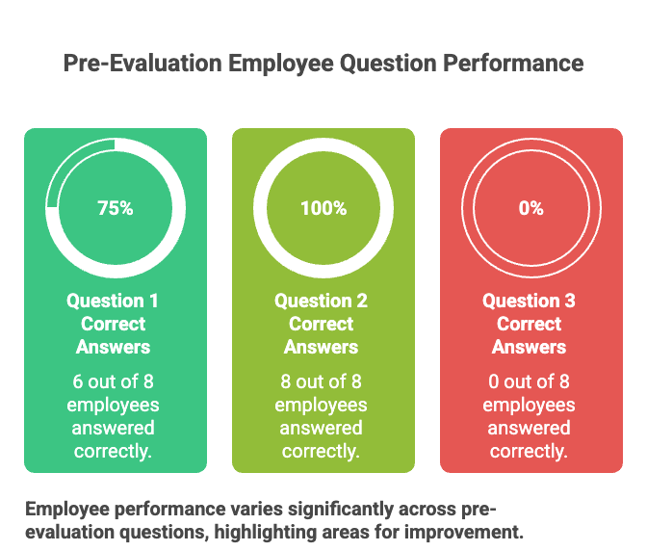

post-evaluation questions :
Question 1: 8 employees out of 8 answered this question correct
Question 2: 8 employees out of 8 answered this question correct
Question 3: 5 employees out of 8 answered this question correct
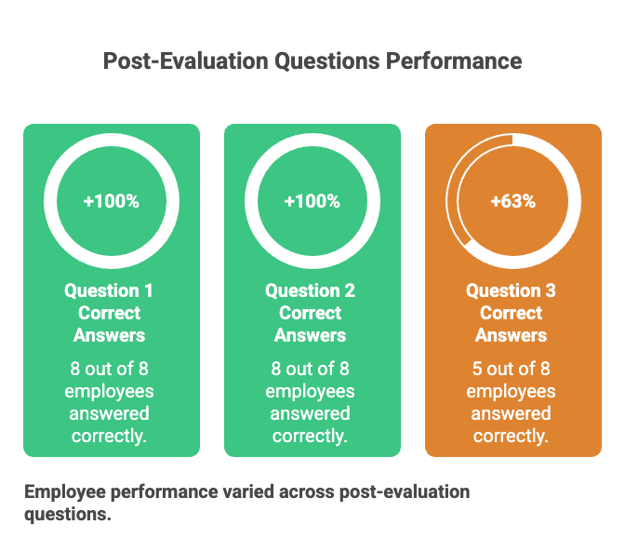
Learning Experience
This training provides ARAMARK staff with hands-on knowledge about food allergens, emphasizing both awareness and practical prevention steps. It reinforces the importance of protecting children with allergies in a school setting and empowers staff to act confidently.
References
Pennsylvania Guidelines for Management of Food Allergies in Schools Recommendations & Resource Guide for School Personnel 2011.
USDA. “Food Allergies: The “Big 9” | Food Safety and Inspection Service.” Usda.gov, 2023, www.fsis.usda.gov/food-safety/safe-food-handling-and-preparation/food-safety-basics/food-allergies-big-9.
CDC. “Food Allergies in Schools.” Managing Health Conditions in School, 18 Oct. 2024, www.cdc.gov/school-health-conditions/food-allergies/index.html.
