Meeting reports

SAFETY HUDDLE MEETING REPORT
Meeting Type: Daily Safety Huddle
Date: February 4, 2026
Time: 9:00 AM
Location: Guthrie Lourds Hospital
Attendees: All Department Representatives and Management

MEETING PURPOSE
The daily Safety Huddle is an interdisciplinary meeting where all hospital departments report their current operational status using the STEPS framework:
- S = Safety
- T = Throughput
- E = Equipment
- P = People/Staff
- S = Service
Departments use a visual indicator system where green lights indicate no issues and red lights indicate problems requiring attention or support.

KEY DISCUSSION POINTS

SAFETY MOMENT
An inpatient neuro code occurred overnight with orders not initially entered by the overnight provider. Quick action by the nursing team ensured orders were placed appropriately and the patient received timely care.

THE GOOD STUFF
Emergency Department Recognition
The team acknowledged outstanding performance by multiple departments in response to a pediatric CPR emergency in the Emergency Department yesterday:
- Registration quickly identified the patient's critical status
- Emergency Department staff provided immediate intervention
- Laboratory, Respiratory Therapy, Pharmacy, ICU, Labor & Delivery, and Security teams all contributed to successful resuscitation
- Patient was successfully stabilized and transferred to Upstate Medical Center
- ED team recognized for conducting an excellent debriefing session after the event
Action: Special thanks extended to all responding departments for exemplary teamwork and patient care
DEPARTMENTAL REPORTS
CASE MANAGEMENT
Metric | Result
Expected Discharges Today | 30
Actual Discharges (Previous Day) | 35 (103%)
Discharges to Home | 28 (80%)
Discharges by 12:00 PM | 4
Average Length of Stay | 4.58 days
Observation Count | 11 (10%)
Observations >30 hours | 2 (both ADC today)
GIP (General Inpatient) | 0
ALC (Alternate Level of Care) | 9
Social Admits | 1
Open Events | 32
Patient Experience Scores (Top Box %):
- December: 75.64% (ranked 2nd)
- January: 85% (ranked 22nd)
Press Ganey Survey: Results discussed; ongoing monitoring continues.

CENSUS & ISOLATION PATIENTS
- Current Census: 108 patients
- Total Isolation Patients: 29
  - COVID-19: 3
  - Influenza: 1
  - RSV: 12
  - C. diff: 0

SAFETY METRICS
Safety Indicator | Days Since Last Incident
Sentinel Event | 31 days
Patient Fall | 5 days
Patient Death | 4 days
CLABSI (Central Line Infection) | 21 days
CAUTI (Catheter Infection) | 125 days
C. diff Infection | 166 days

SURGICAL SERVICES
Procedure Type | Volume
Main OR Cases | 27
Minor OR Cases | 14
Endoscopy | 6
Joint Procedures | 2
Anticipated Bed Needs | 4
FCOTS (First Case On-Time Starts) | 67%

EMERGENCY DEPARTMENT METRICS
Metric | Result
Total Patients Seen | 78
Admissions - Inpatient | 14
Admissions - Observation | 7
Arrival to Provider Exam Time | 7 minutes
Left Without Being Seen | 0
Left Before Treatment | 1
EMS Volume | 19 (24.4%)
Door to Discharge Time | 174 minutes
Current ER Holds | 21 total

LABORATORY METRICS
- Inpatient Draws Completed by 6:30 AM: 80%
- ED STAT Turnaround Time: 94%

DIAGNOSTIC IMAGING - Turnaround Times
Imaging Type | TAT
X-Ray | 42 minutes
CT Scan | 78 minutes
Ultrasound | 73 minutes
MRI | 105 minutes
Pending MRIs: 5 patients, 6 total exams

STERILE PROCESSING
Status: GREEN
- All sterilizers running normally
- Cart washer repaired after hours (now operational)
- Printer ordered for V-Pro 16 (no expected operational impact)

EDUCATION DEPARTMENT
Issue Identified: RQI (Resuscitation Quality Improvement) Carts
- Problem: Cybersecurity will block RQI carts from GC Medical network without Multi-Factor Authentication (MFA)
- Impact: Staff will need MFA enabled on personal phones
- Concerns: Anticipated staff resistance to requirement
- Status: No workaround currently available; IT and Cybersecurity continuing discussions
- Action Required: Communication plan needed for staff education

INFORMATION TECHNOLOGY
Issue Identified: Authentication Badge Login System
- Affected Areas: Emergency Department and ICU
- Problem: System malfunctions preventing badge login; some users unable to manually log in as backup
- Status: Ongoing investigation
- Priority: HIGH - impacts critical patient care areas

PHARMACY
Urgent Alert: Narcotic Enforcement Agency Inspection
- Timeline: DEA representatives expected onsite within one hour of meeting
- Action Required: All units must ensure Pyxis discrepancies are cleared daily
- Issue: Several long-standing discrepancies identified requiring immediate resolution
- Follow-up: Pharmacy leadership to coordinate immediate department sweeps

SUPPLY ISSUES IDENTIFIED
Equipment Shortage:
- Lack of eye masks reported

ACTION ITEMS
Action Item | Responsible Party | Timeline
Clear all Pyxis discrepancies | All Unit Managers | Immediate (before DEA arrival)
Resolve authentication badge login issues | IT Department | Ongoing - High Priority
Communicate MFA requirements for RQI carts | Education & IT | Within 1 week
Reorder eye masks | Supply Chain | Within 2 days
Continue monitoring Press Ganey results | Case Management | Ongoing

Overall Hospital Status: Operational with identified equipment and IT issues requiring immediate attention. Strong interdepartmental collaboration demonstrated during pediatric emergency response. DEA inspection compliance is current priority.

IDDSI IMPLEMENTATION TEAM MEETING REPORT

Meeting Type: IDDSI Implementation Team Monthly Meeting
Date: February 4, 2026
Time: 11:00 AM
Location: Guthrie Lourdes Hospital
Attendees:
- Clinical Nutrition Managers
- Nursing Representative
- Patient Services Manager
- Executive Chef
- Registered Dietitians
- Speech-Language Pathologist (SLP)
- Director of Food Services

MEETING PURPOSE
The IDDSI (International Dysphagia Diet Standardisation Initiative) Implementation Team convenes monthly to plan and execute the transition from the National Dysphagia Diet (NDD) framework to the IDDSI framework at Guthrie Lourdes Hospital.

Background: IDDSI Framework Overview
The IDDSI Framework consists of a continuum of 8 standardized levels (0-7):
- Levels 0-4: Drink/liquid thickness measurements
- Levels 3-7: Food texture measurements
- Purpose: Provides internationally standardized terminology to describe food textures and drink thickness, improving patient safety and consistency across healthcare settings
Current Status: Guthrie Lourdes Hospital currently uses the NDD framework and is working toward IDDSI implementation.
Anticipated Go-Live Date: End of July 2026

KEY DISCUSSION POINTS

1. CROSSWALK REVIEW: NDD to IDDSI
The team reviewed the comprehensive crosswalk document comparing National Dysphagia Diet terminology and levels to IDDSI equivalents. This mapping is critical for ensuring accurate diet order transitions and staff education.
Key Changes in Terminology:
- Previous NDD terms will be replaced with IDDSI standardized language
- New color-coding system will be implemented across all diet levels
- Updated terminology will appear on menu cards, diet orders, and patient education materials

2. MINCED & MOIST LEVEL 5 DIET (MM5) - SIGNIFICANT CHANGES
Current State at Lourdes:
- The hospital's previous Mechanical Soft diet is currently being served for Minced & Moist consistency
- This is a temporary measure during the transition period
Changes Required for IDDSI Compliance: The transition to IDDSI Minced & Moist (MM5) will result in significantly different food presentation and preparation standards.
Example - Meat Preparation:
- Current (Mechanical Soft): Ground consistency meat
- New (IDDSI MM5): Meat pieces sized to fit between fork prongs (approximately 4mm x 4mm)
Food Safety & Consistency Considerations:
- MM5 level foods can be purchased from existing food vendors, which will:
  - Ensure consistency in food preparation across meals
  - Improve patient safety through standardized portion sizing
  - Reduce kitchen preparation variability
  - Meet IDDSI testing requirements
Vendor Product Testing:
- Medtrition representative will conduct an on-site taste test at Lourdes
- Scheduled: April/May 2026
- Purpose: Evaluate pre-prepared MM5 products for quality, palatability, and compliance

3. LEVEL 7 DIETS - BREAD APPROVAL
Decision Reached: The team received system-wide Speech-Language Pathology (SLP) approval for bread service on both Level 7 diet variations:
- Regular Level 7 Diet
- Easy to Chew Level 7 Diet
Approved Bread Types:
- Soft sandwich bread only
Prohibited Bread Types:
- Rolls
- Wraps
- English muffins
- Bagels
- Crusty breads
- Other firm bread products
Rationale: Soft sandwich bread can be safely consumed by patients on Level 7 diets without increasing aspiration risk, while firmer bread products pose choking hazards.

4. LIQUID CONSISTENCIES - TERMINOLOGY UPDATE
Important Clarification:
- Liquid consistencies themselves will NOT change
- Only terminology and labeling will be updated to align with IDDSI standards
Product Labeling Updates:
Pre-Thickened Juices:
- Currently purchased products already display both:
  - Old dysphagia diet description (NDD terminology)
  - New IDDSI terminology and color coding
- No product substitution required
Simply Thick Bottles:
- Product packaging now includes:
  - Updated IDDSI terminology
  - New IDDSI color-coding system
- Staff can reference these labels for accurate preparation
Reference Materials:
- Educational slides with IDDSI liquid terminology and color coding will be available:
  - In kitchen preparation areas
  - On patient care units
  - For staff reference and training

5. SYSTEM-LEVEL EDUCATION INITIATIVES
Update from Melissa (System Representative):
Oracle Learn Module Development:
- IDDSI training module may be combined with Stroke education module
- Rationale: Dysphagia is common post-stroke; combined education improves efficiency
- Target audience: Nursing staff, dietary staff, allied health professionals
Physician Education:
- Will be separate from Oracle Learn platform
- Format: Brief informational blurbs designed for busy physician schedules
- Delivery method: To be determined (email summaries, pocket cards, quick reference guides)
- Content focus: Diet order changes, new terminology, patient safety considerations

CURRENT PROJECT STATUS

Menu Mapping Progress
Task: Mapping current menu items and available food inventory to IDDSI diet levels
Status: In progress
Owner: Julie Leonard, Clinical Nutrition Manager
Completion Date: January 31, 2026 (recently completed)

SLP Review Phase
Task: Speech-Language Pathology team review of mapped menu and food items for IDDSI compliance
Status: Scheduled
Owner: Samantha Koncak-Brown and SLP Team
Completion Date: February 28, 2026

Vendor Product Testing
Task: Schedule and conduct taste test of Minced & Moist Level 5 products with Medtrition representative
Status: Planning phase
Owner: Julie Leonard
Scheduled: March/April 2026

ACTION ITEMS
Action Item | Responsible Party | Due Date | Status
Complete mapping of current menu and available food items to IDDSI diet levels | Julie Leonard, Clinical Nutrition Manager | January 31, 2026 | Completed
Conduct SLP review of mapped menu and food items for IDDSI compliance | Samantha Koncak-Brown and SLP Team | February 28, 2026 | In Progress
Schedule on-site taste test of MM5 products with Medtrition representative | Julie Leonard | March/April 2026 | Scheduled
Finalize Oracle Learn module (IDDSI + Stroke education) | Melissa (System Representative) | TBD | in Development
Develop physician education materials (brief blurbs) | TBD | TBD | Planning
Review and approve vendor MM5 products following taste test | Implementation Team | May 2026 | Pending
Finalize color-coding materials for kitchen and units | Food Services/Clinical Nutrition | June 2026 | Pending

NEXT MEETING
Date: February 18, 2026
Time: 3:00 PM
Location: Guthrie Lourdes Hospital
Agenda Preview:
- Review SLP feedback on menu mapping
- Update on Medtrition taste test scheduling
- Education module development progress
- Timeline confirmation for July go-live

IMPLEMENTATION TIMELINE
Phase | Target Completion
Menu Mapping | January 2026
SLP Review & Approval | February 2026
Vendor Product Testing | March-April 2026
Staff Education Development | April-May 2026
Final Preparations & Mock Testing | June 2026
GO-LIVE | End of July 2026

RISK MITIGATION & CONCERNS
Potential Challenges Identified:
- Staff adaptation to new food preparation standards (MM5 sizing requirements)
- Physician buy-in for terminology changes and new diet orders
- Kitchen workflow adjustments for new preparation methods
- Patient acceptance of reformulated MM5 textures
Mitigation Strategies:
- Comprehensive taste testing before product approval
- Multi-modal education (Oracle Learn + brief physician blurbs)
- Phased implementation with pilot units (if needed)
- Reference materials readily available in all work areas

SUMMARY
The IDDSI Implementation Team is making steady progress toward the July 2026 go-live date. Key accomplishments include completion of menu mapping, system-wide SLP approval for Level 7 bread service, and vendor partnerships for MM5 product procurement. The team is focused on ensuring patient safety, staff education, and smooth operational transition from NDD to IDDSI framework.
Overall Project Status: ON TRACK
• Next meeting February 18, 2026, at 3:00pm.
I am attaching picture for some of the important slides during this meeting
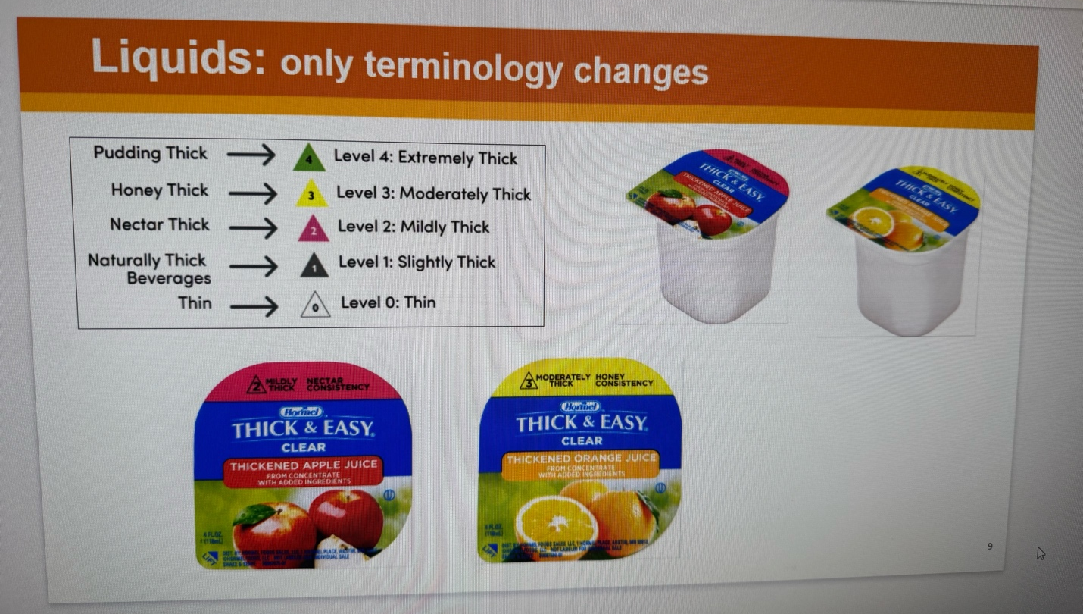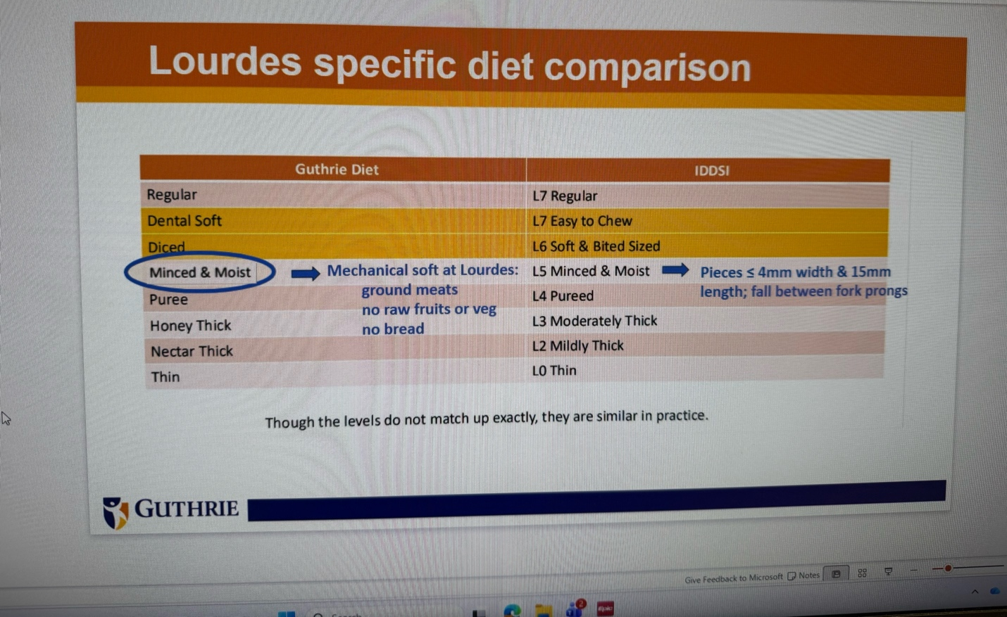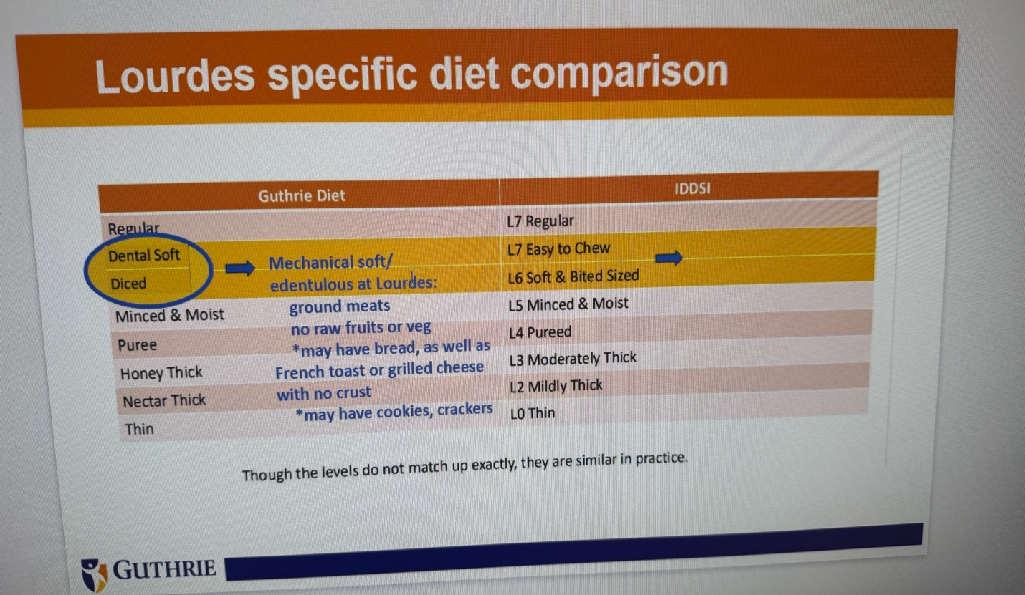

PEG Tube Monthley Meeting
Meeting Type: PEG Tube Monthley Meeting
Date: February 4, 2026
Time: 1:00 pM
Location: Guthrie Lourdes Hospital
Attendees:
- Clinical Nutrition Managers
- Oncology Dietitian
- Nursing Representative
- Registration
This Meeting is happening Monthely to evaluate a project of PEG tube project evaluation, updates, changes, additions, add notes.
this project.
this project ment to help outpatient cancer patients who needs PEG tube to foolow up with the hospitals workers, when and who will change the tube, if they have complications and many other things re;ated to the tube placement, many of the patients used to have problmes when they come to the hospital to change the tube sometimes they got different tube and when they go back home will face problems to flush and more and mmore complications,
in this project the team have communication and spread sheet for all cancer outpatients with Peg to followup with the team , and in this way they will be able to decrease the complication

