Waste reduction
The use of the Offer Versus Serve (OVS) system in schools served by Aramark plays a key role in reducing food waste while giving students flexibility and choice. OVS is a federally regulated option under the National School Lunch Program (NSLP) and the School Breakfast Program (SBP). It allows students to decline certain items from the meal components offered such as milk, fruit, vegetables, grain, and protein, as long as they select a minimum number of components in the required portion sizes. By letting students choose what they actually want to eat, the program minimizes unwanted food being placed on trays, which significantly reduces waste and helps schools save on food costs. At the same time, it encourages students to try a variety of foods, promoting balanced nutrition.
To further strengthen waste monitoring, Aramark has implemented a specialized database system that connects all schools in the district to the main office in the south. Each school records the number of extra meals prepared which is indicated by their production records, and weighs leftover food daily using digital scales. These weight figures are entered into the system, which then converts the total waste into its monetary equivalent. This process allows administrators to track, in real time, how much money is lost due to food waste on a daily basis.
The system is designed with a clear visual dashboard: waste amounts within the acceptable range are highlighted in green, amounts nearing the threshold are shown in orange, and excessive waste is flagged in red. These color-coded signals help school nutrition staff take immediate corrective actions such as adjusting portion sizes, modifying menu choices, or re-emphasizing OVS practices with students to bring waste levels back under control.
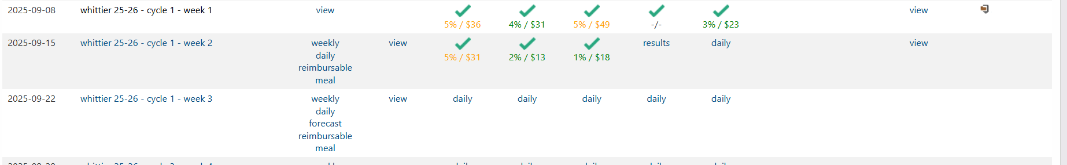

Suggestion
During my rotation, I felt deeply concerned watching large amounts of food being thrown away after lunch. Many students were required to discard unopened milk cartons, whole fruits like oranges or apples, sealed sandwiches, and covered applesauce cups all still perfectly safe to consume. This was particularly difficult to witness knowing that some children in the community face food insecurity.
Because my training was with a private Food service management company (Aramark), I observed that their primary focus is to increase meal participation rates, which directly affects their sales goals. However, current school regulations prevent students from taking any leftover items back to the classroom, even if they remain sealed. To address this challenge and balance food safety with waste reduction, I suggest the following actions for schools and foodservice managers to consider:
- Share Baskets:
Designate a supervised “Share table” or special collection basket in the cafeteria where students can place clean, sealed, or whole items (such as unopened milk, packaged fruit cups, or whole fruit). These items can then be made available for other students to take during lunch or at the end of the day. This idea was suggested by Aramark previously, and it is already applied in more than one high and intermediate schools and Aramark has to watch the tempreture of the food to keep away from danger zone. Items are monitored and discarded in between each lunch service.
- Classroom Food Return Bags:
Allow each classroom to have a labeled basket or insulated container where students can return unopened, nonperishable food or sealed drinks. These can be redistributed at the end of the school day or sent home with the same student.
- Repurposing Fruits and Milk: Use leftover milk and fruits for educational or cooking activities, such as preparing fresh fruit smoothies or yogurt parfaits during nutrition lessons or after-school programs.
- Food Waste Awareness Campaigns: Integrate waste-reduction education into the school’s wellness program. Encourage students to value food and understand the environmental and social impact of waste.
- Partnership with Partner with local environmental or agricultural programs to compost food scraps and recycle milk cartons. This turns unavoidable waste into a learning opportunity.
- Donation for food Banks/ pantries or local community centers or create Cummunity refrigerators in each school. ( this was a suggestion by my Precepteor : Alehea)
For sealed and shelf-stable items, explore partnerships with local food banks or community centers to redistribute save or collect them at the end of each day, unopened food under USDA and state health regulations.

