Introduction
I began my food service orientation with the Aramark K-12 Student Nutrition Program, which is dedicated to serving nutritious and appealing meals in creative and engaging ways brightening students’ days while fueling their futures. The program provides breakfast and lunch to all schools, and some facilities also offer after-school snacks depending on their capacity and resources.
Research and case studies highlight the positive impact of in-class breakfast, showing measurable improvements in student achievement in both math and reading. At South Scranton Intermediate School, for example, students pick up their breakfast bags each morning from a designated breakfast station, ensuring they start the day with healthy energy for learning.
Recognizing that K-12 students value both quality and variety in their meals, Aramark designs chef-created menus with modifications by dietitians to provide healthier choices that not only meet nutrition standards but also enhance overall student performance. The Aramark Food Service Department at South Scranton Intermediate School oversees and manages food service operations for more than 17 schools across the Scranton area, ensuring consistency, efficiency, and high standards in daily meal service. They dael with 17 schools,7 satalite schools 10 production schools, the satalite school only recieves ready to serve meals and the production schools prepare the meals for the students everyday.
School names :
Production Schools | Satalite Schools
John F. Kennedy Elementary School | Adams Elementary School
Northeast Scranton Intermediate School | Armstrong Elementery School
Scranton high School | Morris Elementery School
South intermediate School | Nativity Miguel School
Monticello/Lincoln Jackson | Prescutt elementery School
McNichols Plaza Elementary School | Sumner Elementery School
West intermediate School | Willard Elementery School
Wither elementery School
Isaac Tripp Elementary School
West high School

Partners:
They have partnership program ( fresh fruits and vegetables) in partnership with (Smart Partners) who suppply the schools with fresh produce of veetables and fruits each moth depending on their calender, they also offer nutritional information about these product and give flyers to students to read more about each item, I attached a sample of September calender and a sample of an informative flyer. These fruits and vegetables deliverd to each school in separate prepackaged bags and containers.

Introductions to management, supervisory staff and staff.
127 workers

Tour Department
Receving area
In the receiving area, there is a designated door specifically for accepting deliveries, located close to the main dry storage room, walk-in freezers, and walk-in refrigerators. This area serves as the entry point for all incoming food and supply deliveries, where items are carefully received, inspected, and processed before being moved into storage. The receiving process is a critical control step in the overall “flow of food,” ensuring that all products match purchase orders, meet quality and safety standards, and are handled in a way that prevents theft, spoilage, and contamination.
Staff members are responsible for thoroughly checking deliveries for proper temperature control, physical damage, expiration dates, and any signs of contamination. Each delivery is verified against purchase orders and invoices to confirm the accuracy of items, quantities, and prices. Once approved, products are tagged and labeled with dates and specifications to support proper stock rotation (FIFO) and tracking within the storage areas.
To facilitate efficient movement, carts, boxes, and other transport equipment are used to transfer goods from the receiving dock to the appropriate storage locations. For hygiene and food safety, a handwashing sink is installed near the receiving door, equipped with soap and sanitizer dispensers, allowing staff to sanitize their hands immediately before and after handling deliveries. This design supports both sanitation standards and worker safety, forming an essential safeguard in the overall foodservice operation.

Storage
Proper food storage is a priority for every food service business and commercial kitchen. Implementing proper storage procedures helps preserve the quality and nutritional value of perishables and prevents spoilage. Even more importantly, proper food storage can help prevent foodborne illnesses caused by harmful bacteria.
In this facility, stoarage area is huge and well oraganized, they follow stricts rules depending on HACCP standards. Everyday they are monitoring the labeling and the safety stadrds for this area.
They have more than one type of food stoarage:
Dry stoarage area for all kind of basic requirments, dry food, snacks and others Dry storage is preferable for shelf-stable products and long-term storage solutions for items like canned goods, flour, spices, etc. the ventilation and humidity are controlled ( they use speceial humidity meter ) in each dry storage area, and the food service directore check on all the schools kitchens and storage areas routinly each week to see their complients to the HACCP standards and Aramark standards. Because many items do better when humidity is controlled, especially hygroscopic ingredients like sugar and spices. And I noticed that they have huge big fans all over that area .
They have separate stoaring area for each type of items, they have wire shelving, heavy-duty plastic shelving, hybrid shelving units.

Chimichal stoarage area
Chemicals play an important role in food service operations, where they are used in food production and packaging to help preserve quality, add nutritional value, extend shelf life, and protect food from harmful pathogens. However, their use in or around food must always be safe and strictly controlled.
At the South Scranton Intermediate School, all chemical and pesticide substances are managed in compliance with FDA regulations. The school maintains a designated chemical storage area that is physically separated from food preparation zones. Within this area, chemicals are placed on clearly organized shelves, each container labeled accurately to prevent misuse or cross-contamination. This system ensures safe handling practices and protects both food quality and student health
Disposable stoarage area
Special area only for disposable trays, bags, utensils that all students use in a daily bases, the also have trash bags, ice boxes (empty) and others.
Refrigiration area
This facility had big huge refrigerators because it is considred on of the main producing kitchen for the Satalite schools who don’t produce food , who only receive ready to eat meals each day. These refrigrators were controlled for the Time/temperature (TCS) foods require refrigeration. This type of storage requires maintaining a temperature range of 32°F to 41°F (0°C to 5°C) to prevent spoilage and limit the growth of illness-causing bacteria. Refrigeration storage is best for raw foods and ready-to-eat foods.
Walk-in coolers had specialized shelving that can withstand the cold and humidity of this type of
Freezing area
In this facility they also have walk in freezers for this big amont of food served daily storage preserves the safety of fresh foods for a long time, including highly perishable foods like meats and leftovers. Temperatures kept under 32°F (0°C); below freezing, most food bacteria and other pathogens cease to reproduce.
they have signs and tables all over the area to track tepreture reading twice a day.
Insulated bags and cabinis:
are used to transfer cooked food to satalite schools while. Keeping the tempreture of the food withen the required tempreture

Preparation,
Service and Sanitation
3. Define the production areas (i.e. cold area, cook’s area).
The food service area at South Scranton Intermediate School is designed for efficient, high-volume operation, beginning with the logistical heart of the facility. The Receiving Area is located near an exterior dock, allowing for direct and secure delivery of goods, which are immediately processed and moved into storage. Adjacent to receiving is the Cold Storage Area, comprising walk-in refrigerators and freezers are organized to maintain precise temperature control and separation between different food types, ensuring adherence to health standards.
This area transitions into the large Food Preparation Area. This zone is characterized by stainless steel work surfaces and segregated stations for washing, chopping, and cooking, featuring commercial ovens, tilting skillets, and ample space for the staff to safely prepare the hundreds of meals required daily.
The flow continues from preparation into the front-of-house, centered on the dynamic Food Serving Area. This space employs a multi-line, "scatter-style" configuration to minimize student wait times, offering diverse choices, including hot entrees, a fresh salad bar, and grab-and-go options. Once meals are consumed, thraw their disposable trays, using these disposable trays helps in decreasing the needed time and coast to wash dishes and trays.
The "other" essential components of the overall facility include a staff breakroom, dry goods storage, and a small, dedicated office space for the Food Service Manager to handle administrative duties like menu planning, inventory management, and staff scheduling.
And I tryied to draw this sketch to give you imaginary picture for the raea

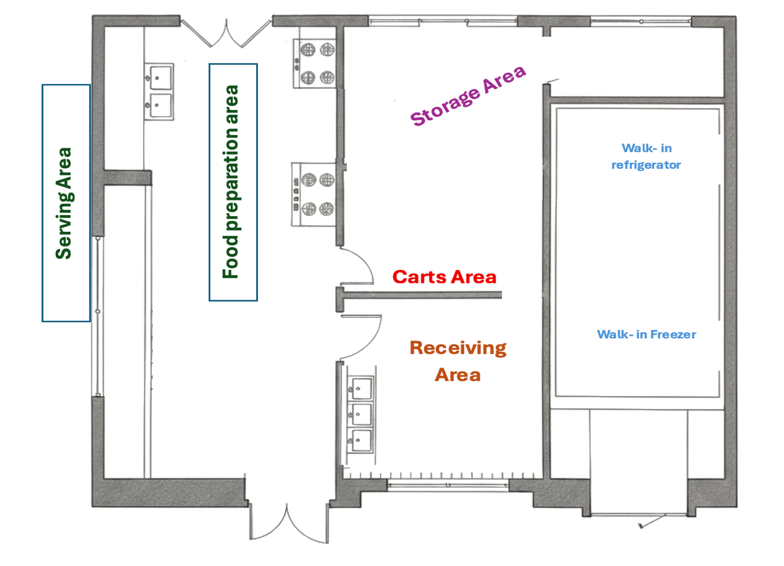
4. What are some special qualities of the employees? (i.e. skills, language,stability)
The employees within the food service department possess a variety of specialized skills and personal qualities essential for ensuring both compliance and efficient operation. Beyond general kitchen experience, specific certifications are mandatory across the team. For example, the HR Manager ,food production supervisor, Chefes and Dietitian hold credentials in their respective fields, ensuring proper staffing practices and nutritional compliance. Crucially, the General Manager and the person responsible for Purchasing and Ordering need strong organizational, budget management, and vendor relationship skills to manage supply chains efficiently. Furthermore, all leads in each kitchen are required to have practical experience in high-volume food production and, most importantly, possess ServeSafe Certification (or an equivalent food safety credential) to guarantee strict adherence to health and sanitation standards.
In addition to formal qualifications, the team thrives on key behavioral and interpersonal qualities, which are vital in a busy school setting. Language flexibility is often a valuable asset, allowing staff to communicate effectively with a diverse student body and ensure every child’s dietary needs or allergy concerns are understood and I noticed that many of the workers and the kids were speaking spanish.
5. What are the hours of operation? (see Production Module)
They do work 8 hrs a day for about 8 days, around 54 productive hours
6. Provide a description of the department (i.e. type of production and service, age of equipment, computer use).
The Food Service Department at South Scranton Intermediate School primarily employs a "cook/chill" which meals will be delivered to satalite schools "speed scratch" production model. While some items (like baked goods and raw vegetable prep) are prepared daily from scratch, many entrees and components are cooked in large batches, rapidly chilled, and then rethermalized on the day of service. This hybrid production approach maximizes food safety and efficiency while maintaining high quality and nutritional standards for the high volume of daily meals. They mostly use recipes and food components that only require quick cooking such as ready to coock breaded chicken fingers, they do bread the chicken fingers on site. The service style is designed for speed and student choice, utilizing "offer versus serve" cafeteria line. Students move through multiple serving stations to select from various hot meals, grab-and-go items, a prominent salad bar, and beverages, allowing them to personalize their lunch and minimizing waste kkeping in minde to use reimbursable meals
The age of the equipment is mixed, core infrastructure, such as walk-in refrigeration units and ventilation systems, may be older but is kept in excellent working condition through regular maintenance. Conversely, high-use items like combination ovens, steam tables, and POS (Point-of-Sale) terminals are often newer, featuring modern energy-efficient designs to reduce operating costs and improve cooking precision. This blend of older, reliable utility equipment and newer, high-tech production tools ensures reliable, safe, and efficient meal preparation and service.
Computer use and technology integration are essential to the department’s operation. Kitchen staff rely on tablets or terminals for accessing digital recipes, production schedules, and inventory tracking systems to minimize errors. For the front-of-house, Point-of-Sale (POS) and clicking systems are mandatory for tracking student accounts, managing free and reduced-price meal eligibility, and recording sales data required for federal and state reporting.

- How long have the menus been in place? When was the last time the menus were updated? Why were they updated? What is the projected date for revision?
the mene is 5 weekes rotating menue, and they revew the menue weekly and monthly, most of the time they do add a pop up meal to give students opportunity to try new things, and to change the routine and make the kids excited to try the new item in the menue, for example they have special meals for special occasions such as Full time and Christmas time.
- Orientation to facility, Attend a hospital/facility wide orientation if possible.
1. Review organizational chart of the facility.
We did orientation at the facility at the first day and kept taking orientation whever we go to check on one of the 17th schools that they mnage.
- To whom does the Director of Food Service report?
To the general Manager.
- When the department is run by a contract management company, discuss with the Food Service Director the requirements of the contract. Discuss different types of contracts.
17 schools in North Scranton District have 5 years contract with Aramark to offer all students meals during the day.
2. Read the Mission Statement. What are the long-range plans of the facility? Read the progress reports to the administration. Arrange to meet and speak with the patient advocate if possible.
I did read all the missoion, vision and values for Aramark, Aramark's mission for its school lunch program is to support each school's educational mission by providing high-quality, nutritious, and tasty meals that power students for successful futures, and I read the progress report and they showed me the system that they use to manage progress.
The Food Service Director must thoroughly discuss the contractual requirements, which typically cover several critical areas to ensure compliance and quality control.
3. Who inspections or surveys your facility?
the department of agriculture in pennsylvania twice a yers mostly in ( march and october)
- What is the date of the last and the next Joint Commission survey?
During October is the next date and the last one was in january
- What other regulatory inspections are expected, and when will they occur?
Steritech audit (once a year )
- Locate your state health code with your preceptor's help?
chapter 23 in pennsylvania code, (administtrative vew every 5 years)

