The Wright Way to Wellness: Kids Edition



Games to Try at Home
Hopscotch
Tools
Chalk to draw the hopscotch grid, Small rock,
beanbag, or stuffed animal to toss

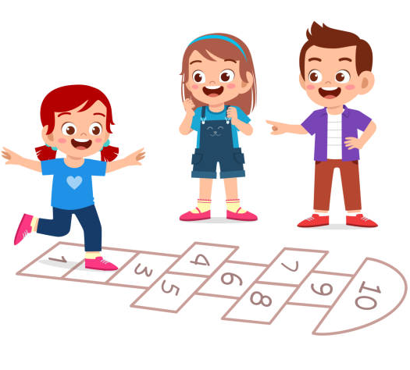
Instructions:
Draw a hopscotch grid on asphalt or concrete with chalk.
The youngest child goes first, with other kids lining up
behind them.
A rock is tossed onto the hopscotch grid.
The player then hops from square to square on one foot, hopping over the square with their rock in it.
At the end of the hopscotch grid, the player turns around and hops back.
On their return trip back to the starting line, the player again skips the square with their rock and also picks up their rock.
Upon returning to the starting line, that player passes the rock to the next person in line and goes to the end of the line. The next player then takes their turn.

Do it your way

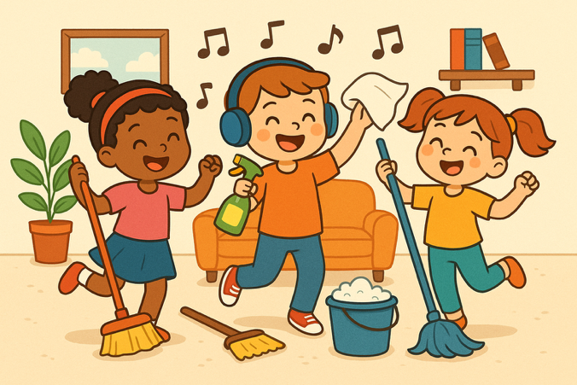
Tools :
music
Instructions:
Clean it like you mean it. Crank up some
favorite tunes and have kids dance to the music as t
hey dust, straighten, put their toys away, make the bed,
help with the dishes or do any other chore

The Wright Way to Wellness: Kids Edition

Land, sea, air

Tools
Tape : to draw line on the Floor
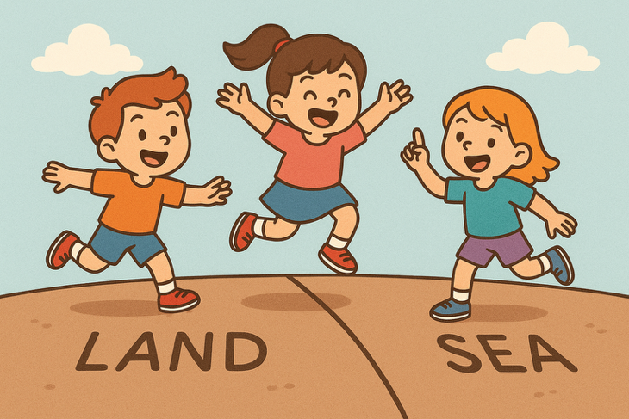
Instructions:
One line on the ground that can fit all players
shoulder to shoulder with elbow room.
One leader will call out commands—”land,” “sea,” or “air.”
Players’ feet should always remain together.
When the leader says, “air,” players must jump
into the air and land in the same place they started.
When the leader says, “land,” players must place their toes behind the line. If they are already behind the line, they must not move their feet. If they are in front of the line, they must jump backward with both feet landing behind the line.
When the leader says, “sea,” players must place their feet entirely in front of the line. If they are already in front of the line, they must not move their feet. If they are behind the line, they must jump forward with both feet landing entirely in front of the line.
Players should always remain facing forward.
If players make a mistake, they must run to a pre-identified location—such as another line—and touch it before returning to the game.

Tug of war
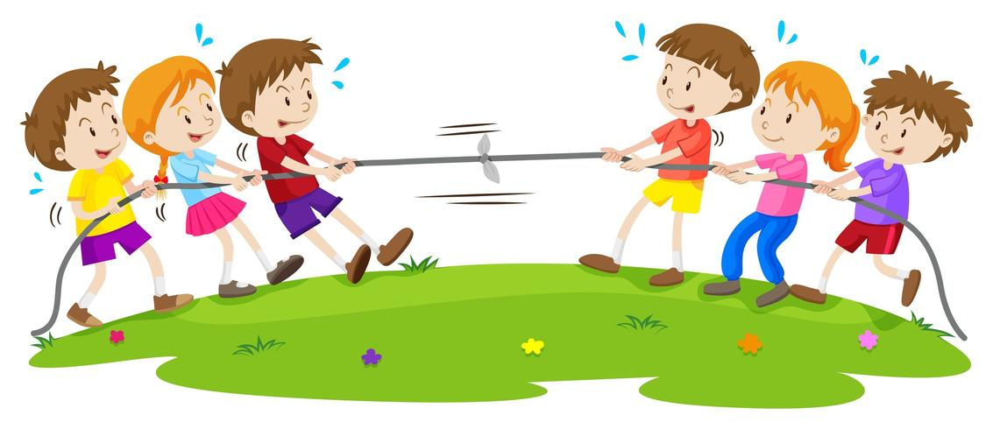
Tools :
8-12 feet of sturdy rope
Masking tape
At least 2 players
1 judge

Instructions:
An equal number of players pick up each end of the rope.
The players begin tugging the rope when the referee gives the signal.
Each player pulls backwards as hard as they can.
The teams continue pulling until the center of the rope (tape mark) crosses where the referee is standing.
The game ends when the referee declares one team has successfully pulled the past the center

