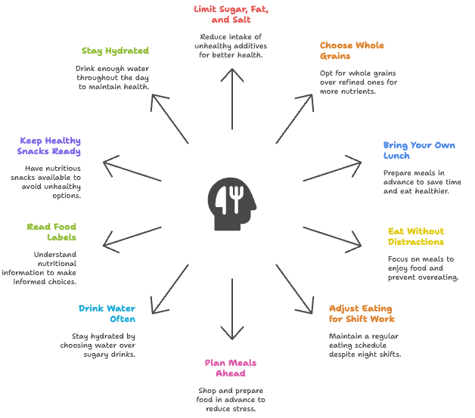
10 Healthy Eating Habits and Tips

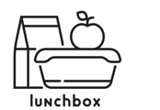
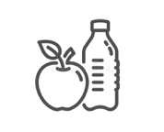
1. Limit sugar, fat, and salt
Added sugar gives calories but little nutrition. It is found in soda, candy, and desserts. Drink water instead of sugary drinks and eat sweets only in small amounts. Saturated fat comes from butter, cheese, whole milk, and fatty meats. Coconut and palm oils also contain it. Choose healthy fats from fish, nuts, seeds, or olive oil. Most of the salt we eat comes from packaged or restaurant food. Cooking at home and using herbs and spices can help lower sodium.
2. Choose whole grains
Whole grains are healthier than refined ones. Pick whole wheat bread instead of white bread, brown rice instead of white rice, or popcorn instead of chips.
3. Bring your own lunch
Plan lunches on weekends to save time. Wash and cut vegetables early, and cook larger amounts of grains or proteins for the week. Leftovers from dinner can also be packed for quick lunches.
4. Eat without distractions When eating,
step away from your desk and put away your phone. Paying attention to your food helps you enjoy it and prevents overeating.
5. Adjust eating for shift work
If you work at night, try to follow a regular eating schedule. Eat a meal before work and have breakfast at the end of your shift. Drink water often, and keep coffee early in your shift only.
6. Plan meals ahead
Use your days off to shop and prepare food. Packing food in advance reduces stress and helps you eat healthier. Taking a real lunch break also lowers stress and refreshes your mind.
7. Drink water often
Choose water over soda or juice. Keep a reusable bottle on your desk and track how much you drink during the day.
8. Learn to read food labels
Food labels show serving size, calories, and nutrients. Serving size: Tells how much people usually eat at one time. Calories: Multiply by servings if you eat the whole package. Nutrients: Aim for less fat, salt, and added sugar. Get more fiber, vitamins, and minerals. %DV: A value of 5% or less is low, while 20% or more is high.
9. Keep healthy snacks ready
Good options include fruit, yogurt, cheese sticks, nuts, or granola bars. Limit processed snacks like chips or candy.
10. Stay hydrated
Most people need about 8 glasses of water per day, but needs vary. Drink small amounts often throughout the day.
Tips:
Keep a water bottle nearby.
Add fruit slices for flavor.
Track your intake with an app.
Drink extra water in the morning.
Choose watery snacks like fruit or vegetables

Grade level on SMOG
• Total sentences: 48
• Polysyllabic words (3+ syllables): 28
• 8th Grade Level

